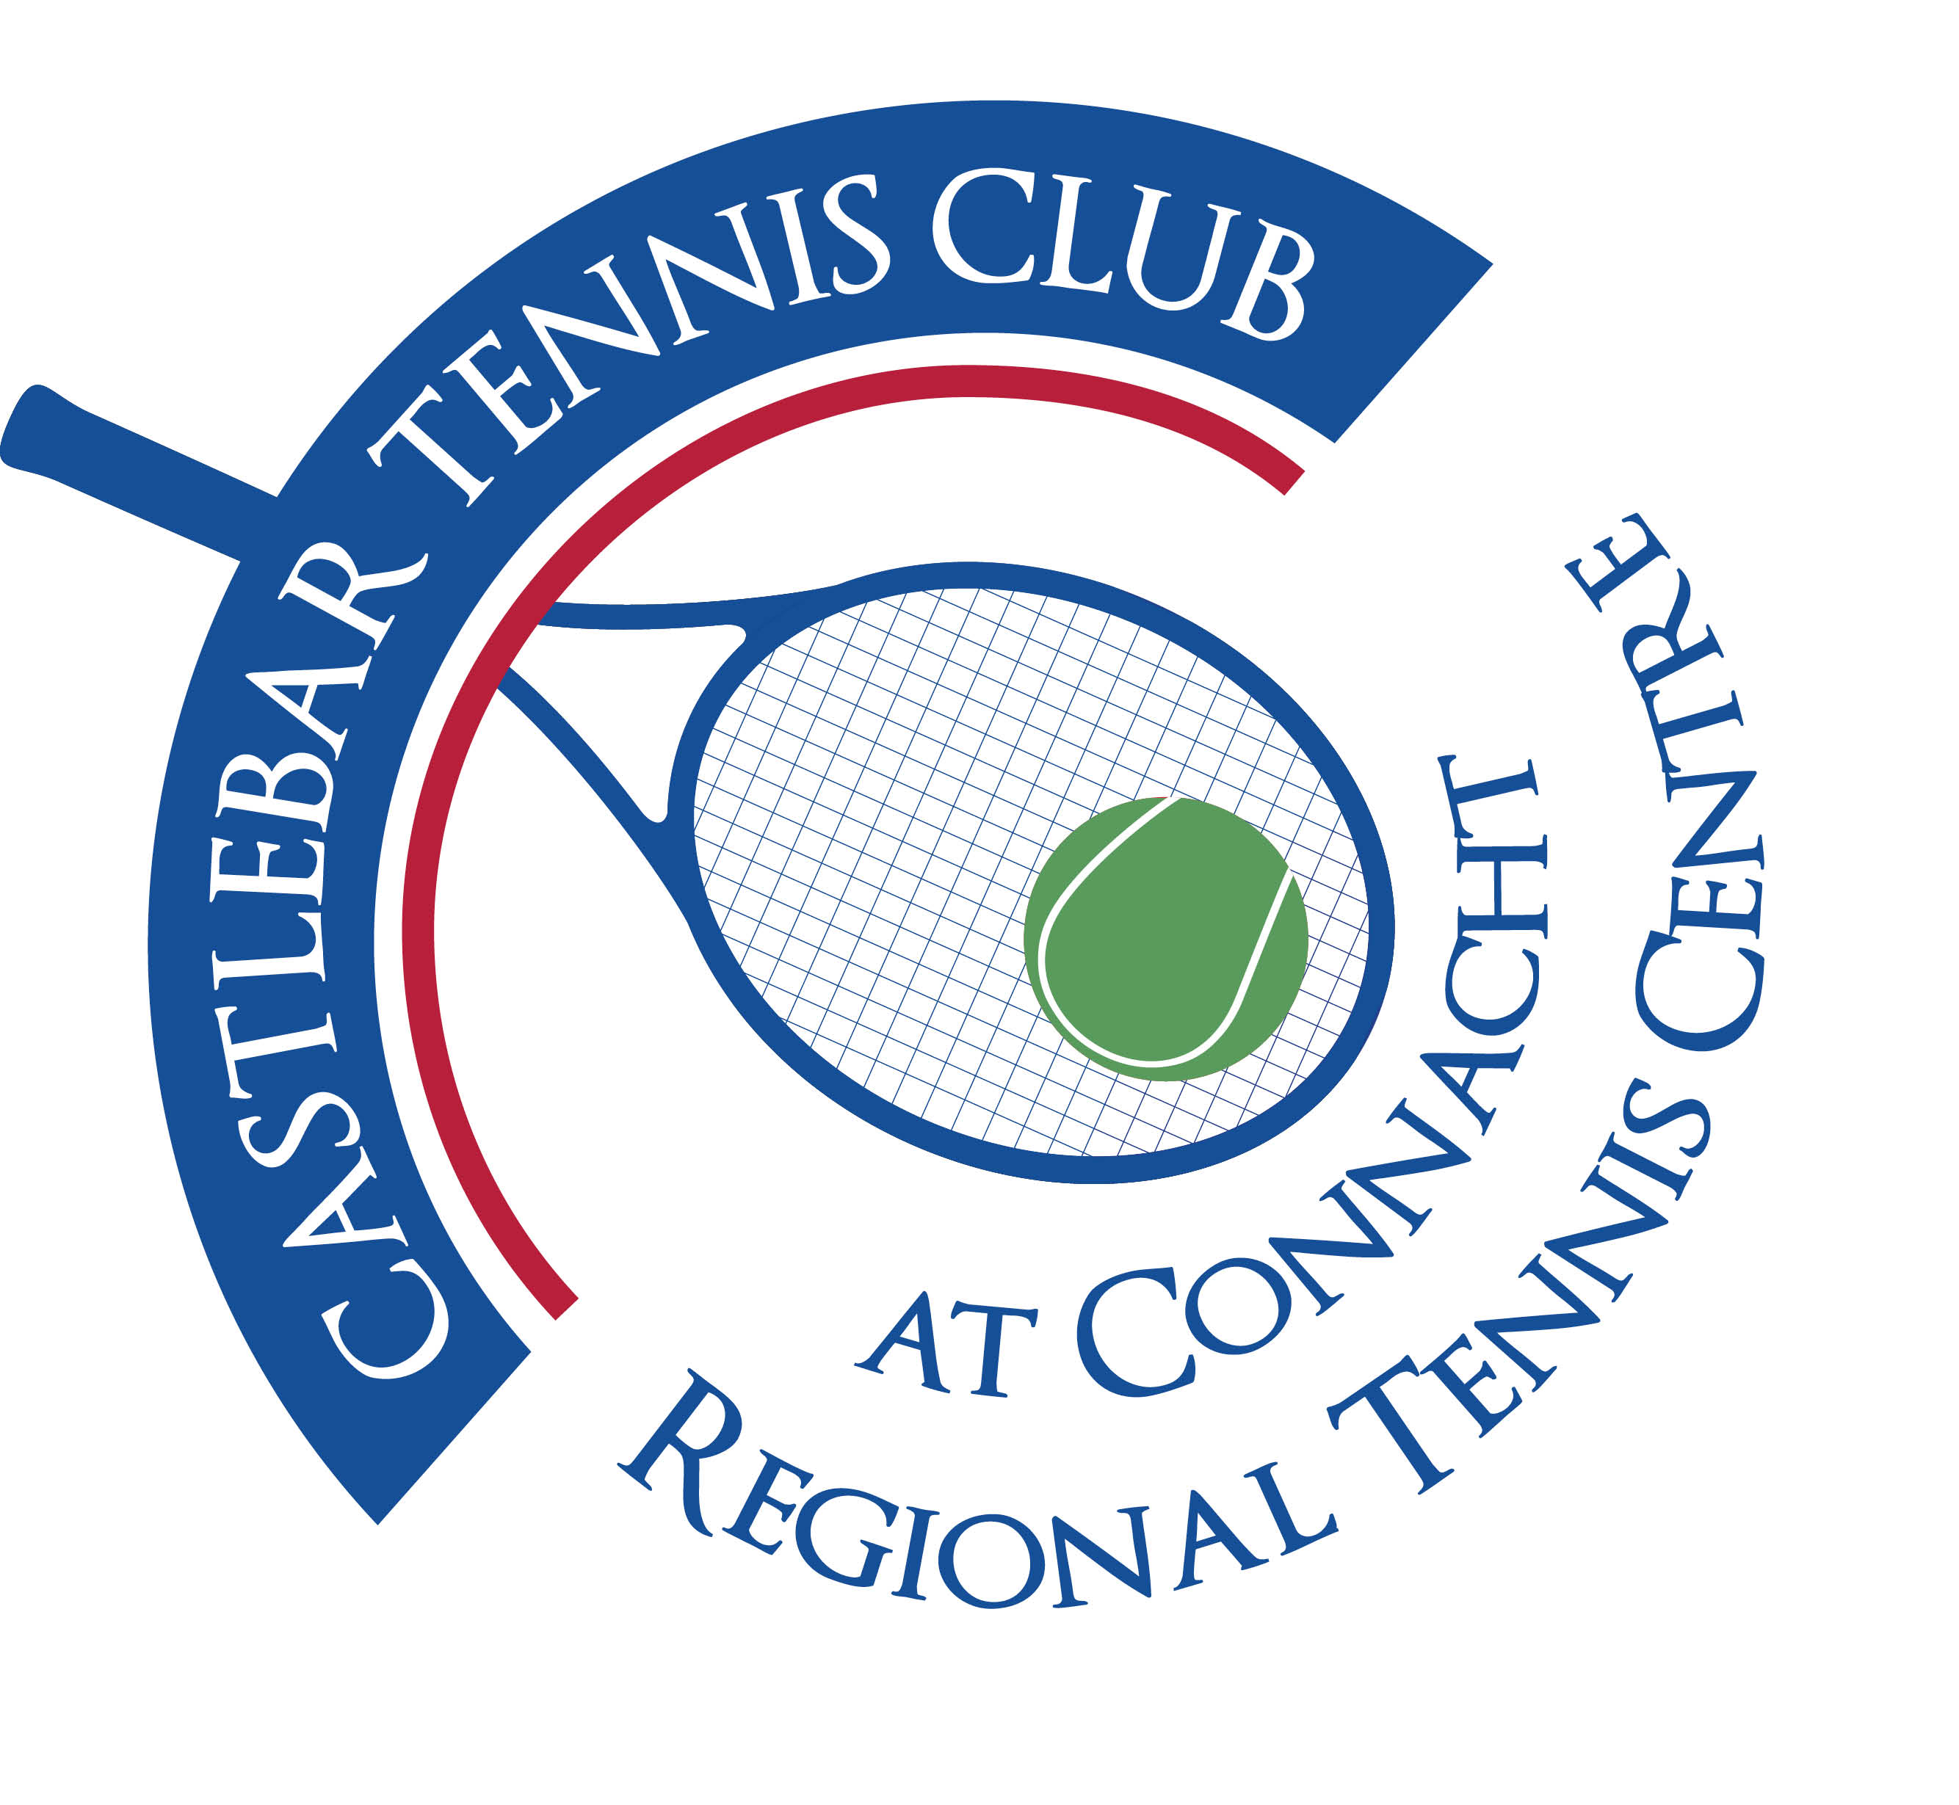

Castlebar Tennis Club

Committee Meeting(Dome)

MINUTES – 29th October 2024

**--------------------------------------------------------------------------------------------------------------------------**

**The purpose of this meeting was to discuss and agree on some decisions that needed to be made so we can move forward with the replacement of the dome.**

**Important points from the meeting:**

* Our mortgage balance plus arrears currently stands at €184k.

By borrowing an additional €170k our monthly repayments will only increase to €3200pm from €3069pm. This is based on repayments over the next 15 years. We should be comfortably able to manage this.

* We shouldn’t need planning for the new dome. It will be slightly higher but not by much(approx 80cm).
* Prunty(€228) and Rocklyn(€298) are the main contenders pricewise(prices are ex-vat). Oth 2 quotes are in excess of €400k. The main benefit of going with Rocklyn would be that they have also installed the new dome in Galway TC, however their after-care service leaves a lot to be desired!
* We need to have 40% of the required finance(in this case €90k) to put in an order for the new dome. Maybe Prunty would be happy to take €50/60k as a down-payment which would mean we wouldn’t need bridging finance.

However if bridging finance is needed Clann Credo is a good option.

* Trustees: Anne Tobin is resigning as a Trustee. She doesn’t have to be replaced, but should really be. We need to contact the other Trustees Paul Heverin, John Kilkelly, Alan Hynes and Liam Nolan to let them know about Anne resigning. Also the trustees will have to sign off on our new borrowings.
* We will need to have an EGM to inform members of any new borrowings(7 days notice needed).
* Car park – enter new agreement with council.

**Plan:**

Noreen to get letters of offer from the bank for the EGM.

Trustees to be informed of what’s happening before EGM.

John to enquire in Credit Union about loan in case rates are better there.