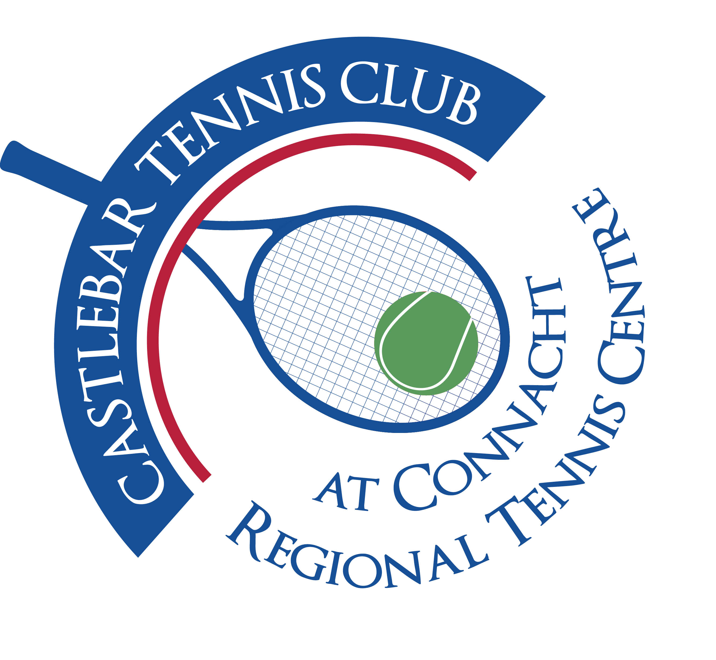

Castlebar Tennis Club

Committee Meeting

MINUTES – 22nd January 2025

**--------------------------------------------------------------------------------------------------------------------------**

Nearly all dome data to follow is obsolete , can we do another dome?????

* **Insurance:** John was in contact with LLoyds bank re storm insurance for domes(Update: **NO** storm cover available unfortunately!!) .

 Tennis Ireland link with AIG specifically for clubs with domes. Patrick spoke to tennis Ireland again to clarify.

* **Car park** meeting last week with Mayo Co Co - open to us installing our own barrier, but they are not interested in a similar arrangement as before. They are happy for us to put up our own barrier and take no spaces. It could operate llike the church car park(€2 to exit, or card tap facility.) We need to consider trial memberships and hall users, etc.

Tony mentioned Colemans - have a top-up system to exit. Members would have a card-no cost. Donie looking at quotes to install coin/card barrier systems.

**Dome: Prunty** thinks the ring beam is undersized and needs to be checked by engineers. €275k approx. **Rocklyn**: we are waiting on a report from structural analysis. They are happy with the ring beam. €25k more expensive - €300k approx.

Dome supplier costs have increased - we need revised quotes. The dome crowd needs to sign off for the banks and for insurance companies.

* **Finance:** **AIB** would not consider giving us a loan.

**Credit Union** loan for 350K will take out our mortgage.

* **Sports Capital Grant** - no problem using our grant funding for a dome. We need to input information on portal.

* **AGM:** Message to go to members with an update tying with AGM notice and drive for new members.Notice of AGM to let members know what's happening and then talk to trustees. Email to members from chairperson Patrick Quinn (Update:message was sent out)
* **Court Sponsorship:** Have agreed to €5k for 3 years. Need press release, Paul to do a sign/big cheque. Update court name on Acebook system.
* **Captains:** No successors yet!(Update: John Greenan is new Men’s captain!)

* **AOB:**
  + New members need a subcommittee to look after. Saturday morning open supervised session.
  + Move forward block booking courts to 7:00 p.m. for a trial period.Just two courts.
  + Lions club running a community event with eight clubs including the tennis club.

‘The Cube’ event in TF. 16 people in total winners get 25,000. $8,000 for each club.

* Table quiz?
* Treasurer's report: 90,064 Euro in bank. Accounts for the AGM will be the last 14 months until December 2024. Accounts will run Jan-Dec going forward.