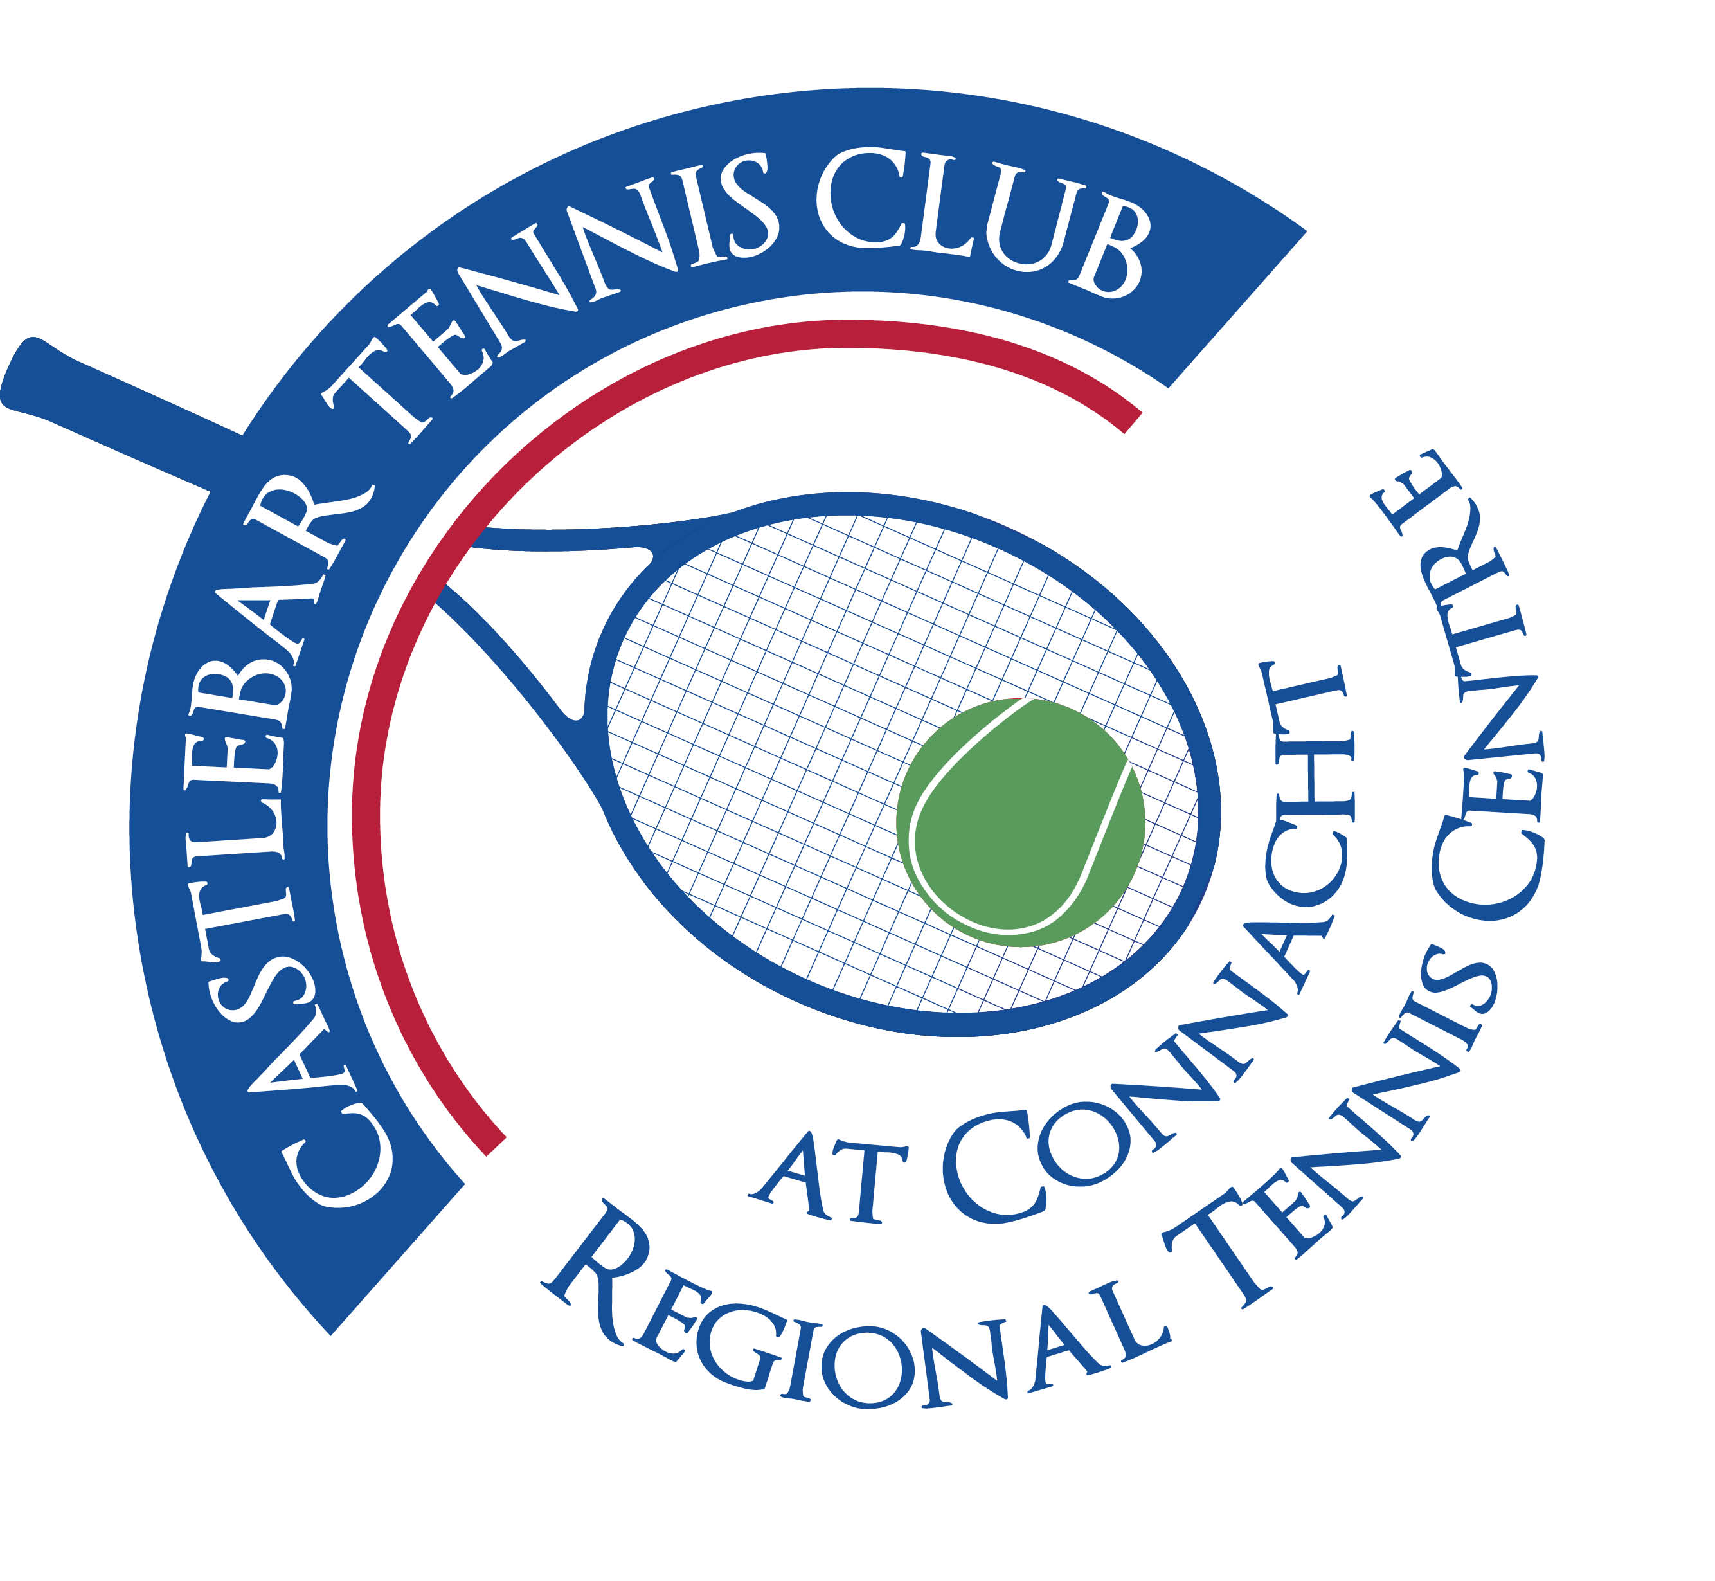
Castlebar Tennis Club
Committee Meeting
MINUTES – 17th December 2025
--------------------------------------------------------------------------------------------------------------------------

Present: Niamh Kilroy, Grainne Cashin, Paul Meldrum, John Feerick, Alma Egan, Noreen McNamee, John Greenan, John O’Malley, Tony Mannion, Emer Dunne

Apologies: Patrick Quinn, James Durkan

1. Chair/Vice-Chair Update:

a. Dome Updates
- Departmental Correspondence: Formal application for reallocation of previously awarded grant (originally for Padel) towards dome submitted in early December.
- Grant Status: Currently ‘in progression for formal approval’; club is 11th in the submission queue; awaiting response before Christmas.
- Process Delay: Department personnel change has contributed to delays
- Insurance Status: Now confirmed available from two providers,
- Financing Plan: 375k total needed, may decrease to €350k depending on final Dome quote.
- Loan Application Plan: Approaching AIB and Credit Union; finalising management accounts with the treasurer to ensure consistency before submission.
- Revenue Updates: Barrier income (car park):
  - September: €852
  - October: €1,854 (junior tournament boosted totals)
  - November: €1,434 (masters boosted totals)
- Signage Needed: Agreed larger sign needed to further promote use of car-park for non-members

b. Padel Court Options
- Two Proposals:
  - Belgian Investment Company:
    - Provides capital; 66.6/33.3 profit split.
    - Club maintains ownership, operates for 10 years.
    - Club responsible for insurance, electricity, day-to-day.
    - Potential: ~€70,000/year net, after part-time salary.
    - Greater control, more attractive management terms.
  - Padel 100:
    - Operator leases club land, provides & manages courts, runs everything.
    - Returns: €8,000/court/year (for three courts = €24k) plus €1 per booking (total ~€28–30k/year).
    - Club hands over most control, 7-year agreement.
    - Less strategic fit for long-term income and club management.
- Discussion Points:
  - Club preference for greater control and autonomy (Belgian offer preferred).
  - Importance of integrating club members via pricing/incentive schemes, but padel will be run as a largely separate venture.
  - Padel appeals to a distinct demographic; expected to draw non-tennis members and generate revenue to support tennis operations.
  - Consideration needed for member vs. non-member booking privileges and pricing.
  - Maintenance of courts will be club’s responsibility under preferred model.
  - Padel courts expected to drive further car park usage/revenue.

2. Club Social & Annual Events
- Saturday, December 20 (Upcoming Social Night):
  - 24 signed up for tennis event; more expected for meal.
  - €10 charge for tennis and meal
  - Meal provided by Ann; volunteers needed for washing up post-meal.
  - Raffle planned (Christmas hamper as prize).
  - Presentations for Captain’s Day tennis, Club Championships and Singles Ladder winners and runners-up during the evening.
  - Plans for setting up tables, decorations, and general club preparation(meet at 11am Saturday morning).

3. Club AGM & Committee Structure
- AGM Planned: Monday, January 26, 2026, at 7:30pm.
- Preparation: Accounts to be finalised by the third week of January, then reviewed by Brendan.
- Committee Changes:
  - Emer and Grainne announced plans to step down—formally thanked.
  - Plan to advertise open committee spots in early January (before AGM) to spur recruitment.
  - Assistant Treasurer position to be created in anticipation of future succession.

4. Grants & Future Development
- Funding Flexibility:
  - Club previously received grant for Padel, now seeking to reallocate unused portion to Dome.
  - Not restricted from applying for new grants once current application is drawn down.
- . External Email: Committee received a fundraising software proposal from Declan McGann from Sutton TC. Unclear if the offering is free, no charge mentioned. Tony to follow up.

5. Junior & Enjoy Tennis Programs
- Enjoy Tennis:
  - €3,000 taken for programme Sept 2024 to Aug 2025; club got €300(10%)
  - Further €500 allocated for Enjoy Tennis initiatives between Dec 2025 and March 2026(email from Jean Barr RDO for Connacht)
- Junior Tournament (January 2026):
  - National “Level 200” singles event: Jan 2–4, 2026. Entry limited to juniors ranked below top 29
- Event Communication:
  - Need to ensure coaching staff notify committee about court usage and ball requirements.

6. Financial Overview
- Current Financials:
  - Total funds: €86,720 (includes €40k earmarked for Dome).
  - Bank breakdown:
    - Main current: €28,000
    - Membership: €7,000
    - Bar: €600
    - Credit Union: €211
    - Miscellaneous cash: vending, bar float, etc.
  - Profit (as of October): €38,000 before annual depreciation.
- Accounts Reconciliation:
  - Discrepancy noted between membership revenue reported by system and Stripe receipts; to be clarified with Freddie.
  - Outstanding debts:
    - €980 owed to club, including €500 from Casey's (junior tournament, unlikely to be collected), and €480 from Mayo County Council.
  - Outstanding liabilities:
    - €1,500 to APM Securities for barrier FOB box.
    - €3,999 to Ken for lights installation/maintenance.
    - €804 to Tennis Ireland Branch (tournament capitation).
    - ~€1,100 for recent tennis balls, purpose to be clarified (resale vs. tournaments).
    - Nothing outstanding for Black Knight hosting (next year's covered with overpaid credit), Diageo bar accounts in credit (€324).
  - Stock assessment (balls, grips, club gear) and year-end stock take planned.

7. Admin, Communications, and Membership
- Club Email Update:
  - Now officially on five club-specific emails (Chairperson, Treasurer, Info, Coaching, Membership)
  - Patrick will update website/contact points; historic email archives retained.
- Membership System Issues:
  - Problem raised re: inability for members to update card details online (Stripe integration/support required). Emer to check with James/Patrick.
- Membership Trends:
  - Slight decrease, less severe than anticipated post-dome removal.
  - Anticipate boost when dome rebuild confirmed.

8. Child Protection, Safeguarding, and Discipline
- Safeguarding Training:
  - Committee reminded that all must complete at least Safeguarding 1; recent completion of Safeguarding 3 noted as time-consuming.
  - Suggestion to coordinate with Mayo Sports Partnership and local GAA club for group training in new year.
- Photo Policy:
  - Strict policy: no children’s names under photos published.
- Disciplinary Committee:
  - Confirmation of who is on Disciplinary Committee (John, Patrick, Noreen).
  - Committee must not investigate abuse allegations, which must go directly to Children’s Officer/DLP.
- Garda Vetting:
  - Checks required every 3 years for coaches and committee.

9. Facilities and Maintenance Updates
- Car Park/Barrier:
  - Car park performing well as revenue source, especially during event evenings.
  - Need for more effective signage identified; suggestion to install large mesh banners and directional arrows.
  - Electric car charging generates negligible income (~€55 total for 2025).
- Lighting & Fire Alarm:
  - Some outdoor court lights and fire panel need maintenance/repair; costs and quotes discussed, with follow-up on best course.

10. Club Gear
- Club Gear:
  - Inventory of leftover/old club gear (mostly small sizes for kids).
  - Plan to design/order new gear in 2026, with input on preferred club colors and logo.
11. Member Update:
  - Prepare and deliver member update at Captain’s Night to communicate real progress and forthcoming changes(dome & padel).

Follow-up & Next Meetings
- Next Regular Committee Meeting: Early January 2026 (exact date TBD), with business plan for Padel and Dome as prime agenda items.
- AGM: January 26, 2026, 7:30pm.
- Junior Tournament: January 2–4, 2026.
- Enjoy Tennis Programme: Begin planning to utilise additional €500 funding prior to end of March 2026.
- Safeguarding Training: To be scheduled for new committee members in early 2026.
- Connacht Branch Meeting: Scheduled for Saturday, January 31, 2026, at 12 noon, in the McWilliam Hotel Claremorris..Club Representation: Monica appointed as the club's representative.

