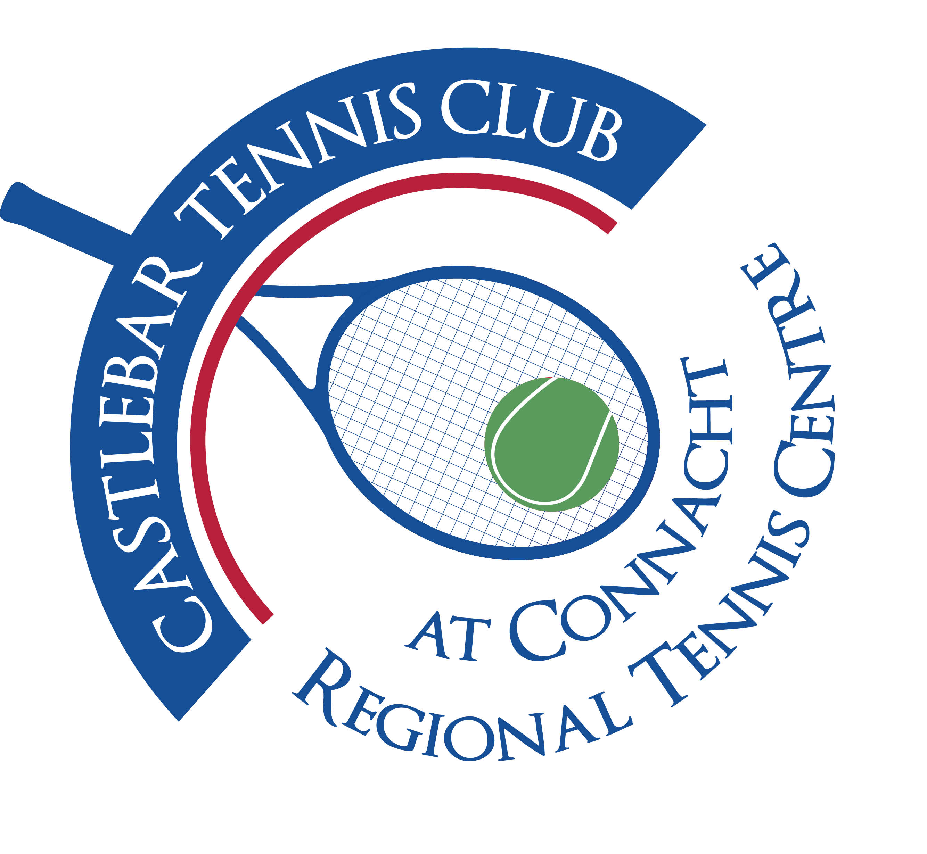
Castlebar Tennis Club
Committee Meeting
MINUTES – 13th October 2025
--------------------------------------------------------------------------------------------------------------------------

Present: John O’Malley, Alma Egan, Niamh Kilroy, John Feerick, Noreen McNamee, Emer Dunne, Tony Mannion, Grainne Cashin

Apologies: John Greenan, Fiona O’Malley
- Minutes
- Previous minutes had been circulated.
- No matters arising; minutes approved without issue.

- Welcome & Vice-Chairperson’s Update – JF

- Updates from Sub-committees
- Membership
Membership packages reviewed and streamlined for manageability.
- Ace books updated; technical issue with some packages not linking to Stripe for payment—Fiona to take up with Fred.
- Payment renewal/extension:
  - 60-day extension to membership terms executed.
  - Issues with double payments when memberships expired and new ones started (noted specifically with Kira Jennings).
  - Resolved by providing credits for overpayments; need to resolve link between Stripe and membership database (Fred assigned).
- FOB system for farm/dance class users:
  - Parents pay €15 deposit for parking fob (returned at term’s end); fob only active for limited pick-up/drop-off times.
  - 20 extra fobs procured for the new term.
- Request to update/automate communications for lapsed or transitioning members.
- Car park lighting: Six bulbs replaced (cost €4,000; two failed after recent storm); issue with glare and possible misalignment; exploring further rectification, considerable finance implications.

- Fundraising & Development (incl. Update on Padel)

Fundraising Progress and Grant Updates
- Detailed update from Noreen.
- €100,000 grant obtained; €40,000 to be used from club savings to access the grant.
- Discussion on using this money for Padel courts even though GoFundMe was raised for the Dome:
  - Committee rationale: Padel is a stepping stone towards ultimately replacing the Dome; generates income & boosts further funding chances.
  - Agreed to bridge a €13,000 shortfall, €5,000 of which to come from Paddy Roland; remaining €8,000 to be targeted from sponsorship/fundraising.
  - Plan to avoid long-term borrowing; possible reliance on short-term bridge if needed.
- Upcoming Sports Capital applications: to open January 2026; preparation work to be initiated.
- Target to have Padel up and running by March/April 2026.
- Club 90th Anniversary: April 27th, 2026—plan for a black-tie event.

Facilities & Planning Applications (John F)
- Planning for Padel submitted last week; roof issue discussed (whether to include full roof now or later, and if it affects planning).
- Dome and permanent structure: awaiting ministerial support, intending to align launches & funding campaigns with Minister for Sport visit to Mayo next month (date TBC).
- Discussion of dome storm protocol(in Galway LTC): tested last week, minor damage (two lights broken); generally performed well.
- Ongoing challenge sourcing quotes and contractor availability due to high demand for Astro/turf installations in the region.

Dome Replacement and Long-Term Strategy
- Dome replacement is a multi-year process with a significant funding requirement (projected c.€500,000).
- Discussion of grant scoring criteria: funding proportion, community engagement, diversity programs, social inclusion, and environmental actions (PV/solar panels discussed as future enhancement).
- Suggestion to ask Bernie for help starting the Sports Capital process; experienced with grant submissions.
- Environmental grants referenced (Climate Action, Leader funding, up to 75% for green projects in some cases).
- Accessibility improvements (disabled access, ramp, double-width doors) still on planning agenda.

Launch & Communications
- Plan for official project launch/event—invite CEO of Tennis Ireland, Minister for Sport, local politicians, council members.
- Need to communicate strategy & financial decisions to members before Minister’s visit and funding launch.

- Treasurer’s Report-NMcN
- Club main bank accounts as of the meeting:
- Main account: €31,912.17
- Bar account: €91.74
- Membership: €7,071.95
- Savings: €54,363.97
- PayPal: €534 ( Junior tournament fees)
- August car parking revenue: €292; September not yet tallied.

- Secretary’s Report – ED
Tennis Ireland increasing Player capitation and court affiliation fees from 2026
New PCF:
Junior €12 (up from €8)
Senior €25(up from €€14)
Family €62(up from €35)
New CAF:
Artificial courts €90(up from €€83)
- Coaching Update
Junior & adult coaching payments now moved to QR code system within the club’s court-booking system (Book a Court).
- QR coding allows for streamlined payment tracking, reduces cash handling, and integrates more smoothly with accounts.
- Feedback that some participants are still paying by cash despite QR system; ongoing transition.
- Beginners/improvers lesson announcements and payment system implementation pending.

- PRO Report – GC
- Outdated references to indoor "Dome" on website and booking system—names changed, need new photos of current courts/facilities.
- Arrangements being made to get access/info from Patrick (webmaster) for updating images and info.
- Club emails managed via Black Knight; hosting possibly moved, clarity needed on current arrangement (Noreen to follow up).

  - Captains/Tennis Report

  - Child Protection
- Standing agenda item; current safeguarding officer position (Dave Roughneen) fulfilled. Also have AnnMarie Reilly so we’re covered.
- Itemised requirements for compliance:
  - Constitution needs a safeguarding clause—minimum text available for insertion, last updated version from 2013; needs review and update for AGM.
  - All members to indicate acceptance of NGB (National Governing Body) guidelines via tick-box in membership process (to be verified).
  - Safeguarding 3 (Garda-vetting/child protection) training required for DLP; others to complete Safeguarding 1.
  - Online safeguarding courses noted to be infrequent; effort needed to get more members through.
- Possibility of teaming up with Castlebar Mitchels,etc to complete safeguarding level 1 with them?

Club Constitution Review
- Current version from 2013; notes from previous (Sue’s) review indicate need to update and possibly restructure as entity (Company Limited by Guarantee proposal paused due to potential stamp duty liability).
- Announced that a standalone meeting will be held to address constitution changes, to aim for updated completion by AGM (suggested deadline: mid-October).
- Several committee members named to be involved; intent to circulate latest version and collate required amendments.
- Noreen to contact Sue regarding current constitution work/progress.

- AOB
- Upcoming tournaments: Junior tournament upcoming; contact ongoing with John for arrangements.
- Vets tournament scheduled for two weeks later.
- Club championship, Captain’s Night, and Christmas drinks calendar to be confirmed; need for publicised schedule/‘save the date’.
- Padel trip to Galway: Galway event logistics covered (participation confirmed, transportation arranged-carpool).
- Panel alarm replacement (related to fire safety): Awaiting new unit, cost not expected to be excessive.
- Club lock-up rota: Request for more member volunteers (especially men for late-night lock-up for safety) to replace reliance on current helpers (notably Paul) due to high time demand.
- Suggestion to form a subcommittee for open/close rota; reminder that some evenings are already well-covered by regular activities.
- Club considering installation of a "kill switch" for all lights to improve ease of switching off after late usage.
- Ongoing transition for Paul to iPad-based booking management—pending Apple ID and set up.

Action Items
- Planning Application
  - Clarify with James if full roof for Padel is to be included in current or separate planning.
  - Seek formal feedback on planning submission status.
- Fundraising Shortfall
  - Pursue corporate court sponsors (target: €5,000 per court); explore fundraising options for remaining gap.
  - Identify members or contacts for sponsorship outreach.
- Preparation for Minister’s Visit/Event
  - Alan Dillon to revert with the Minister for Sport's visit date.
  - Arrange pre-launch meeting(s) with members; prepare presentations, flyers, or looped graphics to communicate plans.
  - Arrange for VIP/council/invited guests and coordinate with Tennis Ireland’s CEO Kevin Quinn.
- Website/Communications
  - Obtain new images of courts, update website and booking system to remove indoor/dome references and highlight current state of facilities.
  - Patrick to provide necessary platform access for updates.
  - Noreen to clarify current club web/email hosting.
- Membership System
  - Fred to resolve Stripe payment and membership renewal issues.
  - Notify/credit/refund any double-paid members.
  - Continue automating expiry date updates and communication flows.
- Constitution/Safeguarding
  - Circulate current constitution; arrange a working group to revise and add required safeguarding text.
  - Ensure Safeguarding 3 training is completed (Alma) and Safeguarding 1 (all/multiple committee members)
  - Verify online tick-box compliance for code of conduct.
- Coaching Admin
  - Complete shift to QR code system for all coaching/lesson payments, including beginners/improvers.
  - Ensure communication about the new system to all participants and parents.
  - Follow up on coaching packages not yet sent by Garrett and team.
- Facilities
  - Review lighting realignment and repair options; engage contractor if needed.
  - Get physical security/alarm issue resolved (Kieran Lavelle).
  - Budget for ongoing replacement/repair needs.
- Car Park Volunteers
  - Issue request to membership for open/close volunteers.
  - Establish rota or subcommittee and define coverage for evenings.
- Event Planning
  - Organise “information evening” for Padel/Dome launch (target: October 24th, 2025, pending development committee).
  - Prepare presentation; print flyers and graphics.
  - Plan captain appointments (seek volunteers, sound out regulars).
- Tournaments
  - Confirm dates and organisers for Junior and Vets tournaments.
  - Post save-the-date calendar for Autumn/Winter social events.
- Green Actions
  - Investigate environmental/climate grants for future dome/roof upgrades.
  - Start documentation of social inclusion and environmental initiatives—may improve scoring for grants.
- iPad Transition
  - Noreen/John/Paul to set up Apple ID and guide through system usage.

Follow-up Points & Next Meetings
- Development committee to be consulted immediately about October 24th target for information session.
- Confirm next standard committee meeting date
- Dedicated constitution review meeting to be arranged (mid-October).
- Ongoing WhatsApp/email check-ins for actions and date confirmations.
- Financial review/budget analysis to continue, aiming for loan rescheduling with the bank based on updated projections and capital funding results.

Notable Dates Mentioned
- April 27, 2026: Club 90th Anniversary Black Tie Event.
- January 2026: Sports Capital grant application window opens.
- Target March/April 2026: Padel launch.
- October 24, 2025: Proposed date for development information evening.
- Mid-Oct 2025: Target deadline for constitution amendments ahead of AGM.

Next Committee meeting tbc

