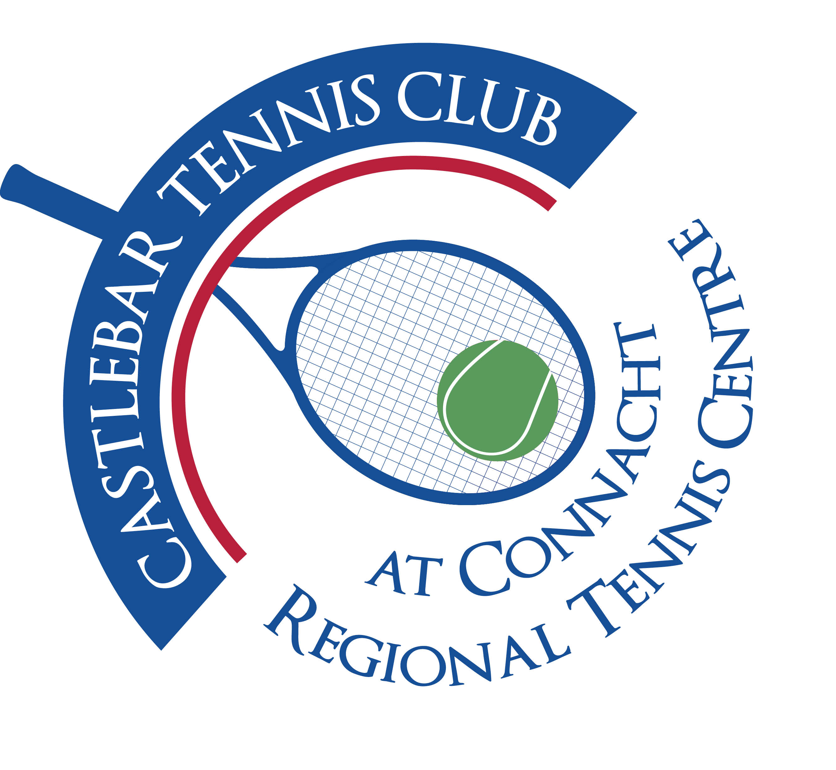

Castlebar Tennis Club

Committee Meeting

MINUTES – 12th May 2025

**Present:** John O’Malley, Grainne Cashin, Noreen McNamee, John Feerick, Patrick Quinn, Paul Meldrum, Emer Dunne, James Durkan

**Apologies:** Niamh Kilroy, John Greenan

1. **Review & adoption of previous minutes –** Proposed by

Seconded by

1. **Chairperson’s/Vice-Chairperson’s Update – PQ/JF**

* **Update on barrier/carpark** - Discussion about providing QR code access to parking for non-members and workers in the area.
* The QR code can link directly to the Pavilion membership page but does not automate membership purchase; users must fill out details and use the mobile app to generate a code for entry.
* Concerns about general public abusing Pavilion memberships for parking; the ability to limit and approve such memberships was discussed.
* A proposal to set up a specific “Parking Membership” capped at 50 was revisited.
* The group resolved to monitor popularity, possibly set member limits, and if needed temporarily remove Pavilion membership as a public option to control uptake.
* It was agreed not to designate parking for council employees only as there are no allocated spaces for club members.
* Go-live for barrier system and QR code access was set for Monday, 19th May. Signage printing and communication to members about the process and app requirements is in progress.
* Discussed need to ensure all junior members’ parents have downloaded the app for access. Consideration given to instructional video/guide for members.
* Protocols for power failure: manual key override available; keys held by Paul and Donie.

Key Figures & Dates:

* Pavilion Membership: €60/year, allows use of facilities and parking.
* Target for print/signage: By weekend before May 19th go-live.
* Go-live Date: Monday, May 19th.
* **Dome Update** - Updates from Hallgruppen and Lauralu (potential suppliers) about quotations and VAT (value added tax) handling.
* VAT issue: Club not VAT-registered, adding up to 20% to project cost (€520K incl. VAT Hallgruppen)
* Lauralu's rental option is €5,000/month, considered unaffordable.
* Contract structuring and risks around middlemen, tendering, and grant eligibility discussed; grants require clear chain of supplier responsibility.
* Confirmed that sports capital grants mandate direct expenditure with project suppliers. Lease/purchase or rent-to-buy options are worth considering but need careful structuring to preserve grant eligibility.
* No relevant grants available at the moment, and concerns raised on immediate financial feasibility.
* Lifespan of potential dome structures (50? Years)
* Decision: Wait for final quotations and continue monitoring grant opportunities.

Key Figures:

* Project Cost (with VAT): Up to €520,000
* Possible loan required: approx. €400,000, in addition to fundraising and grant.
* **Fundraising** **-**
* Credit Union grant applications hampered in the past by lack of active club account there; this will now be resolved.
* Inclusivity grant for €1000 for equipment(eg new club rackets for beginner lessons,etc). Existing rackets are in poor condition and may be cleared out during upcoming spring clean.
* Discussion about member-donated rackets and balls, especially for open days or beginners’ clinics.
* **Membership** - Recognition that adult (especially beginners’) coaching is weak, and new member induction is lacking.
* Need for beginner and improver lessons. Emer to liaise with Garrett to see what coach is available to deliver same .
* Plans also discussed for a six-week beginner and improver programme, ideally starting in early summer, culminating in in-house mini tournament before August bank holiday weekend. Important to integrate new members into internal tournaments to support retention.
* Previous successful member-led clinics and programs referenced; idea to replicate these.
* Consideration for incentives: e.g., bundled coaching with a two- or three-month trial membership at reduced rates, with potential for full membership discount for new joiners.
* Issues: Scheduling is pressured due to busy weekday evenings and competition for courts, but options exist for off-peak times (Saturday mornings, alsoc Monday evenings).
* **Membership Trends and Fee Structures**
* Noted sharp decline in membership: From 265 down to approx 180(adults and juniors) currently-true number of actively playing members lower than this.
* Identified high cost of membership (€600/year) as a primary barrier, particularly for under-40s and younger adults.
* Examples given of members choosing other clubs (Westport, Claremorris) due to lower fees and/or availability of pay-as-you-go.
* Discussion:
  + Consider sliding-scale fees (discounted first and second years, student/graduate/“welcome back” rates, or other incentives).
  + Potential to revisit pay-as-you-go model to attract cost-conscious or occasional players.
* Agreement to review fee structures for both recruitment and retention, while respecting loyalty of long-standing full-fee-paying members.
* **Inter-Firms Competition** **-** discussion about inter-firms event: currently postponed to September, missing optimal summer period and causing delay in accepting a large (€5,000) donation. The importance of timing for member recruitment and club visibility noted.

1. **Treasurer’s Report - NMcN**

* **Finances** – Financial summary:
  + Main account: €23,504
  + Bar account: €2,298
  + Membership account: €2,122
  + Savings: €64,584
  + PayPal: €278
* Outstanding bills: €18,977 for car park barriers (plus €2K for related construction).
* Reviewed options for further cost reduction, e.g., cancelling outmoded till system support, reviewing utilities.
* Electricity- We are changing supplier to Pinergy. Bill for last 12 months: €17,500; would have been €13,700 if we were with Pinergy .
* Suggestion to seek climate action grants for PV solar installation on relevant building aspects to reduce electricity costs.
* Brief update about vending machine repair and associated costs (ca. €1,400); issues with car charging revenue (received small sums so far).
* **Other** – Credit Union account setup is almost complete; waiting on account verification and recent treasurer’s report.
* Plan to deposit car park proceeds directly into this account for easier financial tracking.

1. **Secretary’s Report - ED**
2. **Captains Report – JG**

* Tennis Update – James to speak to John Greenan about starting up Singles Ladder and night(s) for Spring League.

1. **PRO Report - GC**
2. **Child Protection**
3. **AOB**

* **Social Tennis** - Consensus to schedule at least two social events/Fun Fridays over the next few weeks, linked to major tennis events:
  + Friday May 30th (middle of French Open)
  + Friday June 27th (before Wimbledon, which starts Monday June 30th)
* Activities include themed tennis, BBQ, bar nights for both social and fundraising purposes; need to involve broader volunteer base.
* Plans to improve communication/calendar visibility via signage in reception and promotion of a consistent summer schedule.
* Junior Open planned for June 20–22.
* Consideration to coordinate fundraising/social activities with other events to maximize attendance and club engagement.
* **“The Cube”** Decision Point – this fundraising event discussed at length; club would share net proceeds with Mayo Mental Health and other clubs, but participation requires a significant commitment to sponsorship and ticket sales. Club is sceptical about ability to pull enough volunteers and resources together. **Issues:** Diminished membership base (now c. 182 members in total, down from 265 in the “dome strategy” era); fundraising fatigue among members; doubtful return compared to in-house fundraising. Consensus reached (by lack of enthusiasm and explicit votes) to decline participation in the Cube and focus on internal, club-serving initiatives.Priority at the moment is to get our own house in order(increase membership/dome/padel/carpark,etc)
* **Padel** – Would bring in money/ attract 20/30 year olds
* If we run with padel we would be classed as a multi-sport facility which would open up other potential funding streams
* It would operate for general public as pay-as-you-go so would open up the club to the public a bit more(tennis clubs seen as private clubs)
* If we run with padel it would give some good news to members and be seen as progress in the interim while we are trying to secure funding for covered courts.
* Discussion on using ring-fenced €40,000 dome fund for investment in padel courts, which could serve as a pay-as-you-go revenue source and potential membership draw.
* Concerns about eligibility for sports capital grants if club resources are redirected; need to review funding guidelines.
* Risk flagged: If other private/commercial operators move first, club could miss out on local padel demand.
* Administrative steps:
  + Need to check and update planning permissions and ensure sufficient supplier quotations are available and up-to-date.
  + Three supplier quotes have been received; we have SCG of €100,000 on a €170,000 application, still short, but scale and provider pricing needs rechecking(we can get 3 new quotes if we so wish)
  + We would need to look at obtaining Clann Credo bridging finance

**Next Committee meeting to be held on Monday June 9th at 7pm.**