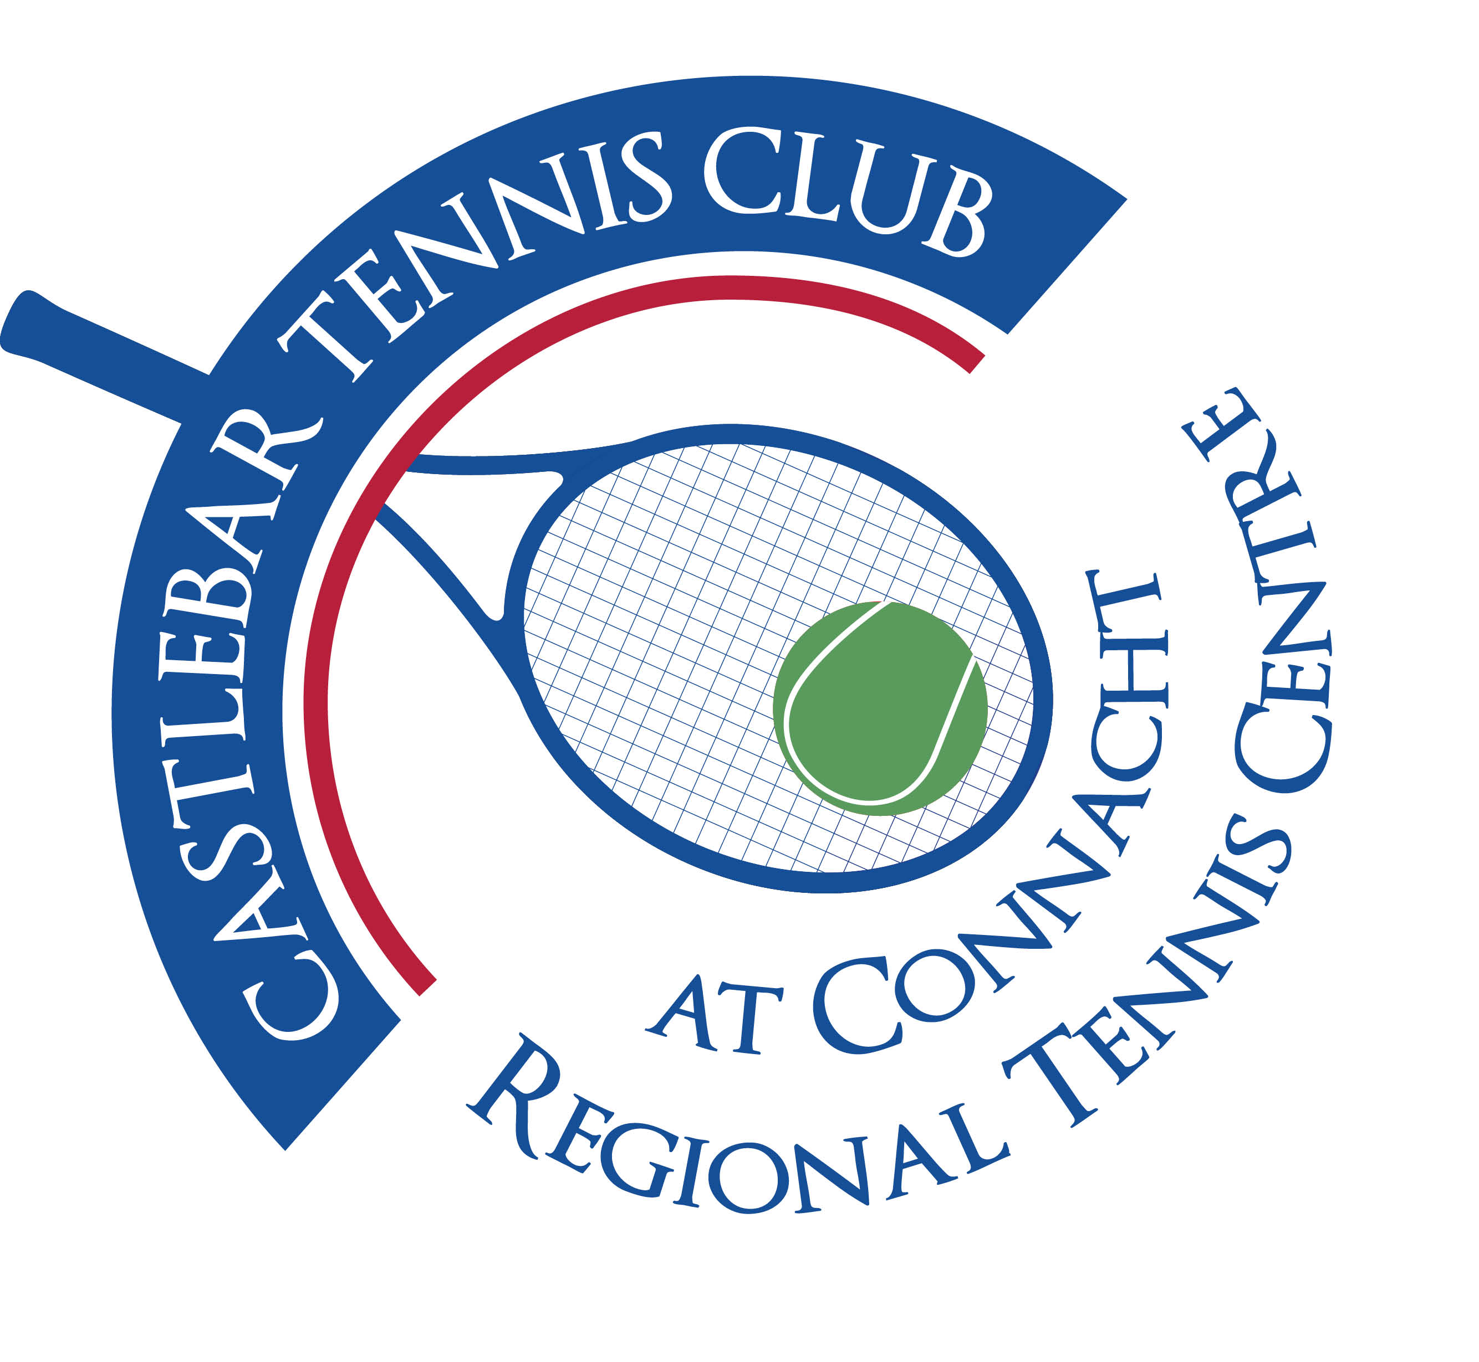

Castlebar Tennis Club

Committee Meeting

MINUTES – 6th February 2025

**--------------------------------------------------------------------------------------------------------------------------**

**Present:** John Feerick, Grainne Cashin, Paul Meldrum, Alma Egan, Noreen McNamee, Fiona O’Malley, John O’Malley, Patrick Quinn, Emer Dunne

**Apologies:** James Durkan, Niamh Kilroy

**Club Meeting: AGM Plans, Storm Impact, Membership Strategy**

Club Meeting Summary

Main Topics Discussed

1. AGM Preparation

* **Date**: Scheduled for next Thursday 13th February at 7pm.
* **Notice Distribution**:
  + Emer sent the AGM notice via email.
  + Some members did not receive the email due to non-membership status.
  + Alternative distribution methods considered, including WhatsApp & FaceBook reminders.
  + A poster was created & printed, displayed on noticeboard and shared through WhatsApp.
* **AGM Agenda**:
  + Review of the previous year’s activities and performance.
  + Presentation of various reports:
    - **Chairperson's Report**
    - **Treasurer's Report**
    - **Coaching Report** (to be prepared by Garrett)
    - **Child Protection Report**(to be prepared by Bernie)
  + Election of new officers.
  + Discussion of any other business, including the club’s future direction.

2. Impact of Storms on Club Facilities

* **Dome Structures**:
  + Current domes now withstand wind gusts up to 120 km/h, reduced from the previously stated 160 km/h.
  + Expected to be damaged and require removal 3-4 times annually.
  + Additional challenges:
    - Need for anchoring and potential additional membrane coverings.
    - Reliance on members to manually remove domes, making insurance and financing options unfeasible.
* **Fixed Structures**:
  + Exploration of fixed structures as a long-term solution.
  + **Quotes Received from CI Sprung**:
    - 2 court option: €833 + VAT
    - 4 court option: €1.28 million + VAT
  + **Cost Comparison**:
    - Aluminium modular structures are approximately four times the cost of existing domes.
  + **Current Status**:
    - Garrett and Rocklyn are reassessing designs to include air holes and future-proofing against storms.

3. Financial Strategies

* **AIB Loan Refinancing**:
  + Plan to approach the credit union to refinance the existing AIB loan.
  + Current repayment: Approximately £3,000/month.
  + Target repayment: £1,500-£1,800/month over 10 years.
  + Requires member approval at the AGM for new borrowings.
* **Grant for Padel**:
  + Grant received in September with a two-year utilization window.
  + **Decision Points**:
    - Use the grant to install Padel facilities, advancing club development.
    - Release funds back to the government to seek larger grants for a permanent structure in the future.
  + **Considerations**:
    - Releasing the grant may affect future funding opportunities.
    - Need to consult with Alan Dillon for strategic political and funding support.

4. Car Park Issues

* **Urgency**:
  + Current car park is overfilled, affecting court accessibility and posing safety risks with kids running across.
* **Barrier System Installation**:
  + Proposal to install barrier systems to manage parking flow and safety.
  + **Estimated Cost**: €15,000 – €30,000.
  + **Funding Options**:
    - Incorporate barrier costs into the refinancing plan with the credit union.
    - Utilise sports capital grants for installation.
  + **Impact**:
    - Potential reduction in available parking spaces.
    - Discussion on leasing advanced systems like number plate recognition for efficient management.

5. Membership Considerations

* **Membership Decline**:
  + Total membership decreased to around 170 active members. Need to attract more/new members.
* **Pricing Strategy**:
  + Need to adjust membership fees in the absence of the dome.
  + **Comparative Analysis**:
    - **Claremorris**: €180 for individual membership
    - **Westport**: Similar price for individual membership.
  + **Potential Solutions**:
    - Put question to members- Do we reduce membership fees? Then we will end up looking for funds towards permanent structure/charge to exit carpark with new barrier system? Would be like giving with one hand and taking with the other!
    - Introduce incentives for new memberships, very attractive rate for first-timers.
  + **Discussion Points**:
    - Balancing fee reductions with maintaining financial stability.
    - Ensuring transparent communication to members about fee changes and facility limitations.

6. Coaching Management

* **Current Situation**:
  + Loss of dome has disrupted coaching activities and revenue streams.
  + **Coaches Involved**:
    - Garrett manages coaching schedules and payments.
    - Olwyn from sports partnership is no longer active.
* **Financial Impact**:
  + Club retains only 10% of coaching income, leading to reduced financial gains.
* **Proposed Solutions**:
  + Introduce an administrative role to manage coaches and memberships effectively.
  + Develop incentive programs to encourage coaches to support membership growth and take on additional responsibilities i.e.part-time manager position similar to the role Dan had.

7. Additional Topics

* **Partnership with Sports Brand**:
  + Interest from a head sports brand representative to partner with the club.
  + **Proposed Activities**:
    - Racket demonstrations and sizing evenings for members.
    - Selling rackets, clothing, grips, and balls at discounted rates through club vending machines.
  + **Benefits**:
    - Enhanced club facilities and member engagement.
    - Additional revenue streams from sales.
* **Junior Tournaments**:
  + Scheduled junior tournaments requiring court availability on weekends (Saturdays 9am-8pm and Sundays 9am-to 6pm).
  + **Financial Consideration**: €300 per weekend rental fee.
  + **Concerns**:
    - Potential loss of court availability for club members.
    - Need for maintenance and cleanliness during tournament events.
    - Update: Garrett happy to leave 1 court free on these dates for members and pay €2.50 per court per hour.

Action Items

1. **AGM Preparation**
   * Finalise and distribute the AGM notice via email, WhatsApp, and printed posters.
   * Prepare and finalise the Chairperson's, Treasurer's, Coaching and Child Protection reports for AGM.
2. **Financial Refinancing**
   * Approach the credit union to negotiate the refinancing of the existing AIB loan.
   * Seek approval from AGM members and present the proposed loan terms to trustees.
3. **Grant Decision**
   * Decide whether to utilise the Padel grant for facility development or release it back to the government for larger future projects.
4. **Car Park Solutions**
   * Obtain detailed quotes for the installation of barrier systems.
   * Incorporate the cost of barrier systems into the refinancing plan.
5. **Membership Strategy**
   * Develop a revised membership pricing structure reflecting the absence of dome.
   * Propose and implement incentives for new memberships.
   * Communicate clearly with members about pricing changes and facility limitations.
6. **Coaching Management**
   * Develop an administrative role dedicated to managing coaches and memberships.
   * Create and implement incentive programs to encourage coaches to support membership growth and take on administrative tasks.
   * Re-establish or renegotiate coaching agreements to ensure better management and support for club operations.
7. **Partnership and Events**
   * Organise partnership events with the sports brand representative, including racket demonstrations and sales events.
8. **Additional Facility Improvements**
   * Plan improvements to lighting systems, considering the installation of energy-efficient LED lights and potential solar panel integration.
   * Explore options for introducing new facilities, such as mini gym or additional amenities in the shed area.
   * Ball machine demonstration session.
   * ‘Think tank’evening-members come and share ideas to help with fundraising,etc