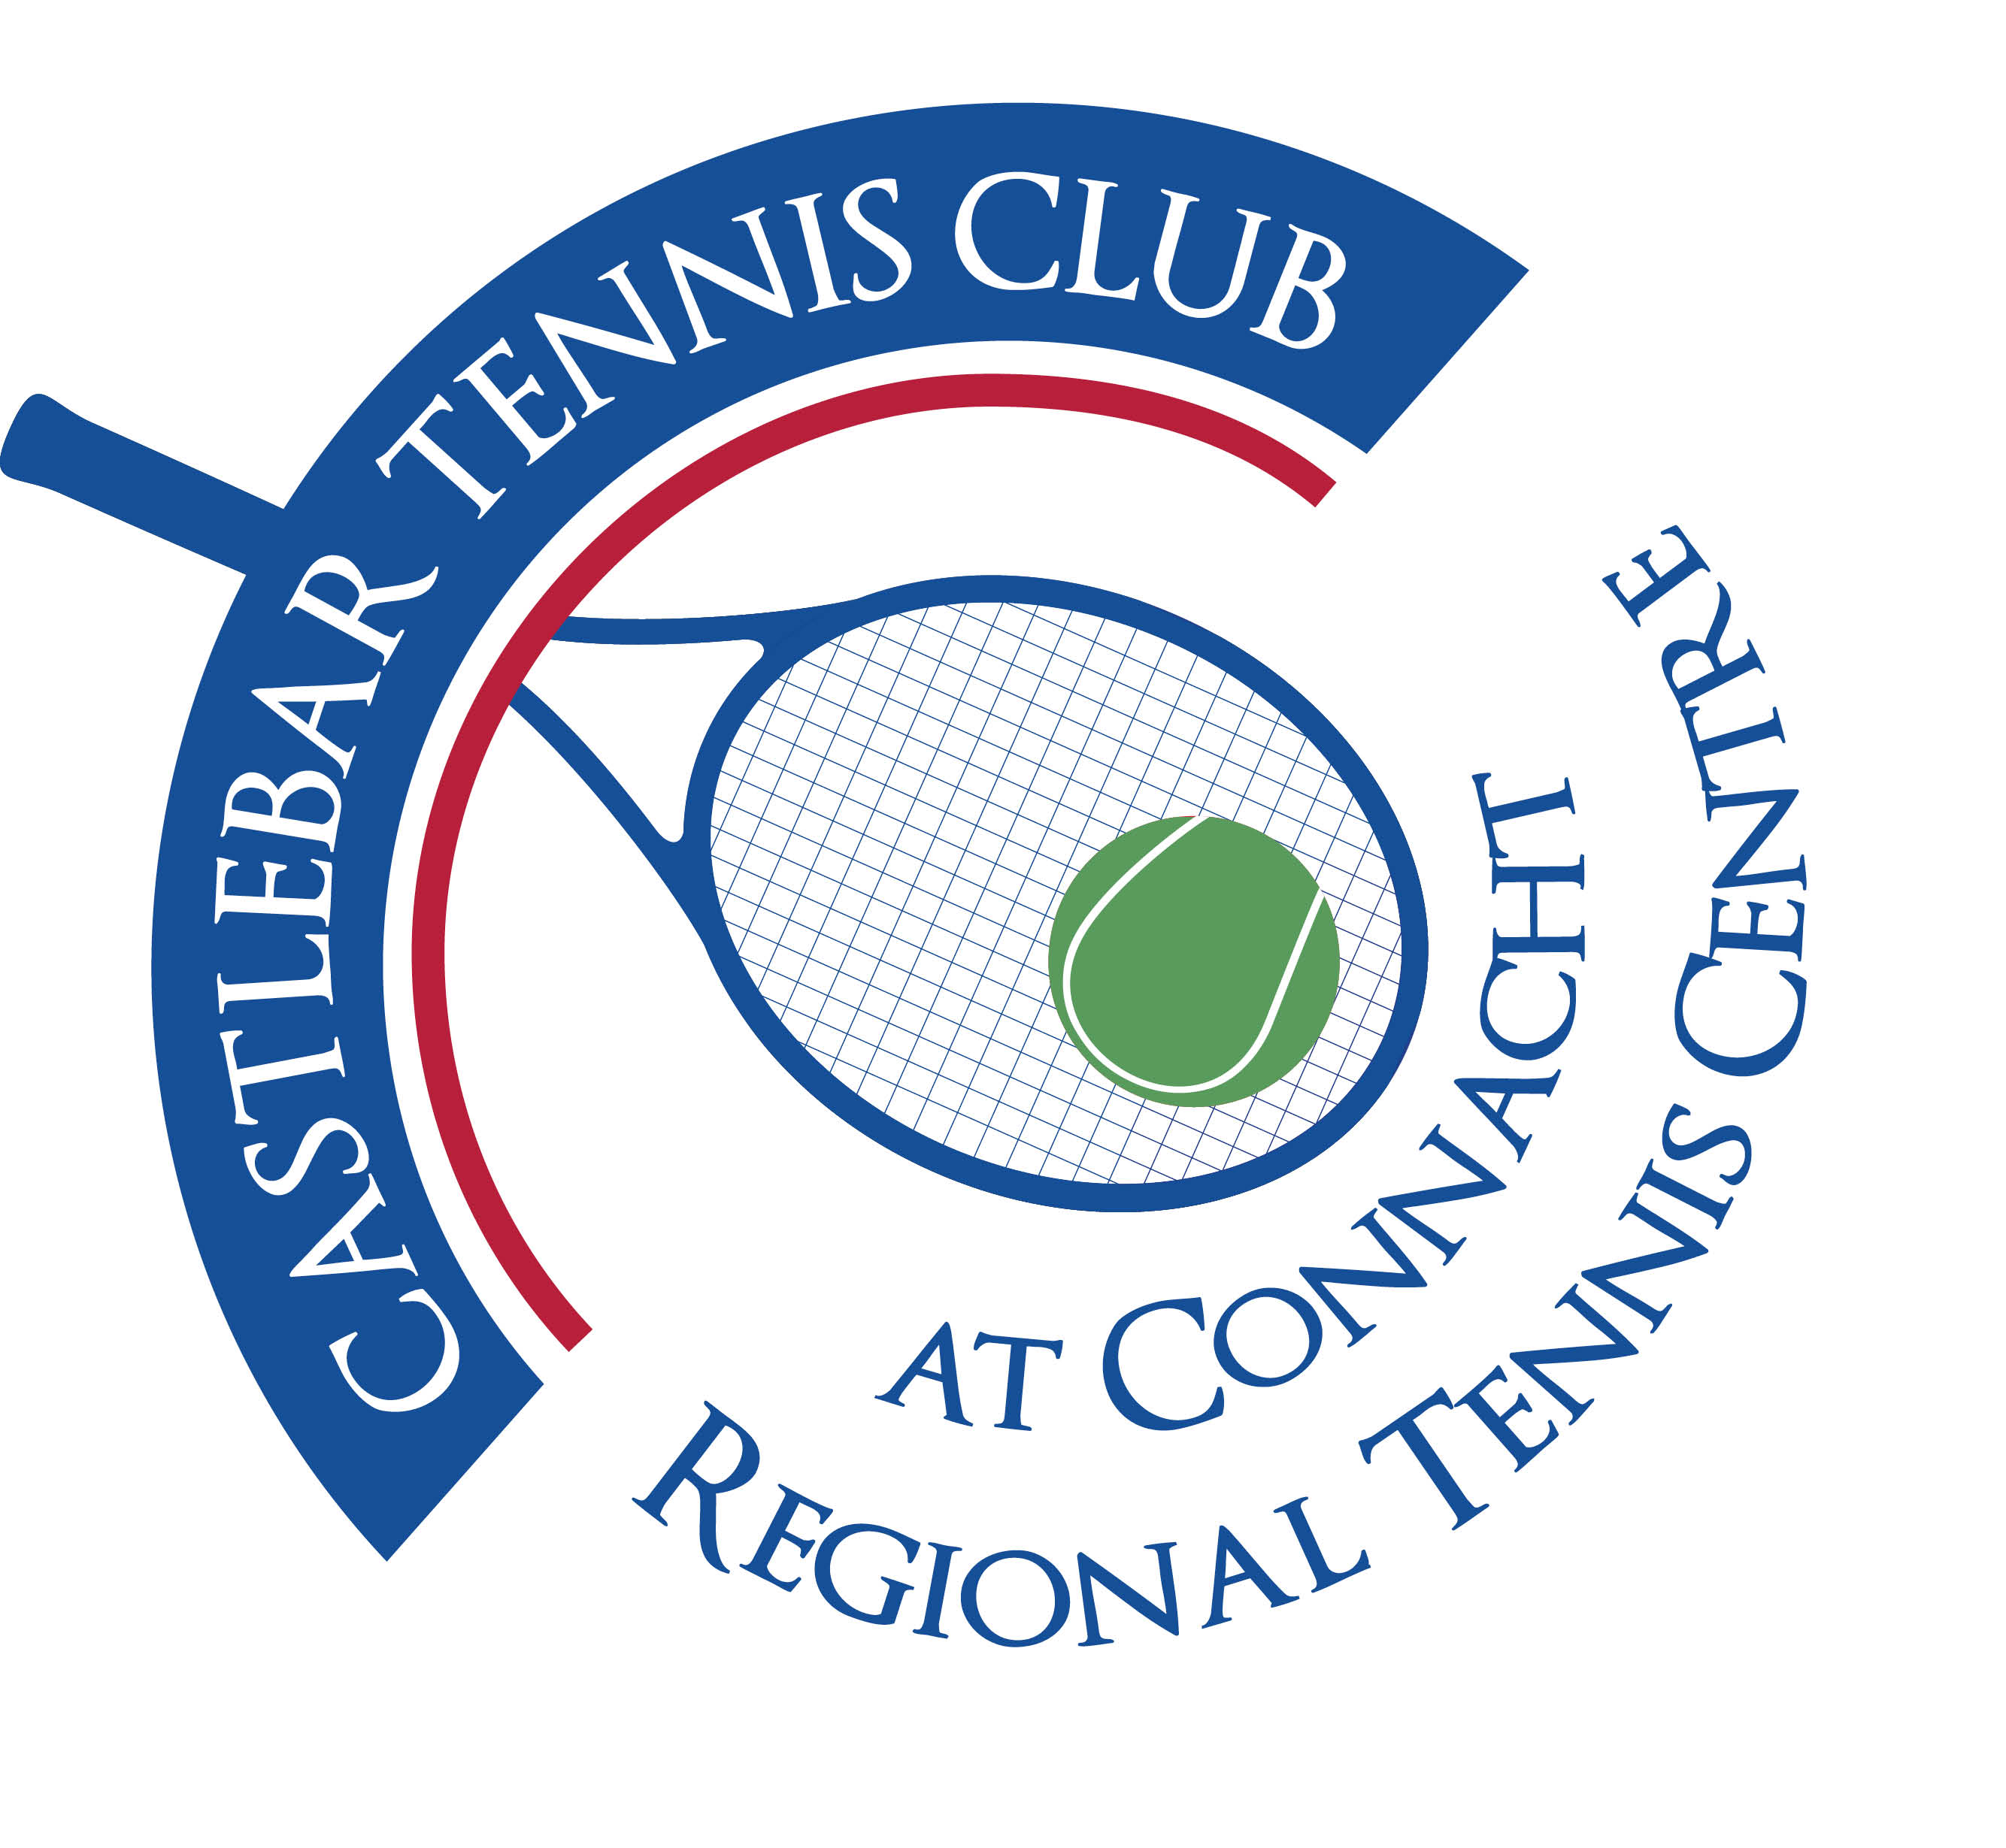

Castlebar Tennis Club

Committee Meeting

AGENDA – 4th September 2025

**---- Present:** John O’Malley, Alma Egan, Niamh Kilroy, James Durkan, Paul Meldrum, John Feerick, Noreen McNamee, John Greenan, Emer Dunne

**Apologies:** Tony Mannion, Grainne Cashin, Fiona O’Malley

1. **Minutes**

* Previous minutes had been circulated.
* No matters arising; minutes approved without issue.

2. **Vice-Chairperson’s Update:**

* August Bank Holiday Review

Attendance and Numbers:

* Widely regarded as a very successful weekend; possibly the highest attendance to date.
* Over 200 participants, marking a milestone.

Financial Review:

* **Sponsorship Income:**
  + 2023: €300
  + 2024: €2,150
  + 2025: €2,000 (from two main sponsors, Pam and E.)
* **Net Entry Fees (after refunds):**
  + 2023: €6,324
  + 2024: €5,666
  + 2025: €7,907
* **Total Tennis Income:**
  + 2023: €9,324
  + 2024: €7,816
  + 2025: €9,907
* **Net Tennis Contribution (after costs):**
  + 2023: €2,688
  + 2024: €773
  + 2025: €2,533

Social Side Financials:

* **Bar Income:**
  + 2023: €4,500
  + 2024: €2,724
  + 2025: €2,900
* **Kitchen/Barbecue:**
  + Bridie’s Kitchen 2024: €1,300; 2025: €915
  + Barbecue 2024: €390; 2025: €1,900
* **Net Social Contribution:** Just over €3,000 (€3,072)

Overall Event Contribution to Club Finances:

* 2023: €6,153
* 2024: €3,021
* 2025: €5,605

Key Observations:

* Financials bounced back in 2025, mostly due to a more successful barbecue and higher net entry fees, though bar income has declined since 2023.
* The tournament is becoming increasingly competitive, reflected in increased singles entries and more serious tennis.

Sponsorship Evolution:

* 2025: Two sponsors (€1,000 each Thea Pharma and Pamex)
* 2024: Multiple smaller sponsors (Ellison €500, Thea Pharma €500, Quinnee €500, Hastings €350)
* Discussion on the potential to expand sponsorship further in future years.
* Homecoming Event for Athletes
* Celebrated achievements of Lauren and Eoghan.
* Dignitaries, including Alan Dillon (local TD), were present; highlighted as an important opportunity for networking and political advocacy.
* Recommendation: Continue leveraging local politicians and influencers when large developments are planned.
* Facility and Development Updates

Parking and Sports Hub Developments:

* High activity and growth mentioned: Additional parking for pool/gym under tender, expected in 2026.
* Section 8 provision allows for expansion without additional planning due to inclusion in original plans.

Ministerial and Funding Updates:

* Alan Dillon (TD) promised to arrange a meeting with the Minister for Sport in coming weeks regarding the upcoming Sports Capital Grant (opening January next year).
* Recommendation: Club to apply for €500,000 as a regional application.
* Discussion about timing and eligibility of simultaneous grant usage, especially regarding unspent funds from a €99k grant—clarification is needed to ensure funds are properly allocated and not penalised for non-usage.
* Padel Court Project & Club Expansion

Feasibility, Funding, and Timeline:

* Subcommittee met to discuss overall plan and fundraising until the Sports Capital grant application.
* Potential for a group site visit to experience padel courts in action (Galway a possible location).
* **Estimated costs:** Approximately €600,000–€620,000 for comprehensive development (four courts and supporting infrastructure).
  + Club currently has approx. €40,000 in funds (from GoFundMe), but will need to secure further grants, member support, and possibly bridging finance.
* **Revenue Projections:** Based on padel court rental in Galway (€48/hour), projected club income could be substantial, but exact numbers require validation and cost deductions.
* Strategy: Use padel courts to fill membership gap among 20–40-year-olds, grow club revenue, and improve applications for larger grants and future expansion.

Phased Fundraising Plan:

* **Short-term:** Run smaller fundraising events this year to bridge into 2026.
* **Medium-term:** Target sports capital grant (January application), aim for large-scale fundraising in conjunction with roll-out.
* **EGM (Extraordinary General Meeting):** Planned for mid-October to present proposal and gather member buy-in; aiming to meet with Minister for Sport in advance.

Preparation and Administrative Steps:

* Current quotes for courts, need for groundwork contractor bids.
* Plan is to build for two padel courts (groundworks to support possible future expansion to three).
* Member engagement is key for funding success.
* Fundraising options discussed: mix of member events, external celebrity participation (e.g., potential to bring in Mundy for event in TF Theatre), and corporate court sponsorships.
* Membership Structure and System Review

Problems Identified:

* Current member categories overly complex and confusing for new joiners.
* Too many categories: various adult, country, trial, family, student, pavilion, and junior variations.

Proposed Changes:

* **Junior/Juvenile:** No changes.
* **New Student Rate:** €120/year or €10/month for college students.
* **Young Adult Rate:** Up to age 25 at €240/year or €20/month.
* **ATU Academic Year Membership:** €80 (September–May), targeting students not resident over summer.
* **Adult Renewal:** Remains €600/year.
* **New/Returning Adult:** €360 for first/returning year (if away >2 years); includes four weeks coaching.
* **Family Membership:** €840/year (2 adults, children under 18); clarification needed on family definition.
* **Country Membership:** Unchanged, but three-month country membership to be abolished—should be a yearly follow-up after trial.
* **Corporate/Institutional:** To be treated flexibly, not as standard published packages.
* **Special Annual Offers:** Limited (e.g., summer/winter specials for new members), but no ongoing “stop/start” memberships.

Retention/Reward:

* For this year only, all current full-year members get two extra months (total 14 months for the price of 12).

Membership Administration:

* All membership queries are now routed to Fiona, with improved email notification and administration.
* System simplification to ensure clarity for users (both current and prospective).
* QR code integration for event and green fee payments is being increasingly used; identified as a helpful administrative tool.
* Coaching Program, New Members, and System Use
* Ongoing improvements to Acebook system for coaching, Green Fees, Fun Fridays.
* QR code system facilitates bookings, tracks coaching payments, and helps data-collection on prospects who have not joined as full members.
* Specific push to integrate coaching with new member package (four free weeks of lessons).
* Discussed ways to ensure coaching access for both beginners and intermediates.
* Coaching schedule flexibility considered (e.g., on Friday evenings up to 8 pm).
* Reminder: All members must select partners when booking courts—system will prompt green fee payment if guests are included.
* Club Night, Autumn League, and Events
* New Members Night ongoing, supported with posters.
* Ladder matches and social events active and well-attended.
* Suggestion to run a "Freaky Fun Friday" before Halloween as a themed social event.
* Proposal for autumn league before Vets Tournament( Nov 14th-16th) possible use of Saturday evenings to improve court utilisation.
* Junior competition planned for October 29th–November 2nd.
* Grounds & Facilities, Barriers, and Maintenance
* Maintenance: Ongoing costs are significant (€5–10k per year), including repairs to lights and other infrastructure.
* Mortgage: Club continues to pay €3,000/month; €60k in arrears will extend repayments by about two years.
* Bar license renewal: Relevant certification submitted to Fire Officer, waiting to hear on possible inspection, court date for licence renewals is scheduled for Friday September 26th.
* Child Protection & Safeguarding
* Club must complete and submit a 10-point Tennis Ireland safeguarding checklist.
* Some items outstanding:
  + Male children’s officer needed.
  + Some required training incomplete.
  + Club constitution revision to formally reflect safeguarding guidelines required.
  + Completion of risk assessment and display on website pending.
* Immediate action: Checklist to be completed and gaps identified.
* PR & Communications
* Positive media coverage after recent events.
* Instagram and Facebook presence improving, with more social media activity.
* Suggestions made to further leverage social and local media coverage for club events and activities.
* Miscellaneous/Other Points
* Potential new water filling station for the clubhouse discussed; costs and details pending.
* Coffee shop or container setup adjacent to the club is a possible project for the future.
* Ongoing consideration for a covered viewing area (possibly as part of future dome construction).
* Corporate sponsorship drive to be revisited; potential to increase court sponsor partnerships.
* Action Items

Event and Sponsorship:

* Increase sponsor numbers for next year.
* Expand and diversify fundraising efforts leading into 2026.

Grant and Development:

* Meet with Minister for Sport and Alan Dillon (TD) prior to EGM (target mid-October).
* Clarify grant eligibility and implications for current €99k funding.
* Obtain additional quotes for padel/groundworks; ring potential local contractors urgently.
* Organise site visit to Galway padel facility.

Membership:

* Update website and membership system to reflect simplified categories.
* Remove or phase out three-month country membership option.
* Ensure family/country member criteria are strictly verified (requires proof of other club membership).
* Promote new schemes and special offers as agreed.

Coaching & Administration:

* Meet with coaches (Daniel and Garrett) next week to finalise autumn coaching plans.
* Roll out QR code booking and green fee tracking training for administrators and coaches.
* Implement system whereby every player booked on a court is listed, facilitating guest fee collection.

Child Protection:

* Complete and submit safeguarding checklist; identify and address key gaps.
* Secure second children's officer; encourage nominations at EGM.
* Update constitutional language to reflect safeguarding guidance.
* Finalise and upload updated risk assessment to website.

Fixtures & Social:

* Plan and schedule autumn leagues, ensuring diverse usage of courts (especially weekends).
* Organise themed social events (Halloween "Freaky Fun Friday", etc.).
* Expand publicity efforts to attract new members (posters, social media).

Facility and Maintenance:

* Continue timely payments on all outstanding invoices (e.g., contractors, Tennis Ireland, bar license).
* Investigate costs and feasibility of coffee stand for longer-term amenities plan.

Financials:

* Prepare management accounts up to end of August for bank, including projections for coming year(s).
* Liaise with bank regarding mortgage extension versus restructure; coordinate with Credit Union as development plans progress.
* Follow-Up Points & Planned Meetings
* **Ministerial Meeting:** In coming weeks, to discuss grant applications and clarify funding rules.
* **Coaching Meeting:** With Daniel and Garrett next week to finalise autumn lessons and new member coaching.
* **EGM:** Plan for October, with date to be set post-ministerial meeting; main focus on fundraising and padel court proposal.
* **Groundworks/Contractor:** Immediate follow-up with potential local groundwork contractors for quotes.
* **Safeguarding Review:** Complete and submit Tennis Ireland checklist ASAP; additional actions as determined.
* **Ongoing Administration:** Continuous system review for memberships, coaching, and court bookings.
* Points for Next Meeting
* Review progress on grant clarification and padel court project.
* Status update on child protection compliance and appointments.
* Feedback on membership system changes and impact.
* Financial position and projection update.
* Confirmation of autumn/winter event schedules and new member retention.
* Report back on contractor availability and groundwork estimates.
* Any updates on sponsorship and corporate engagement.

**Next Committee meeting tbc.**

**----------------------------------------------------------------------------------------------------------------------**