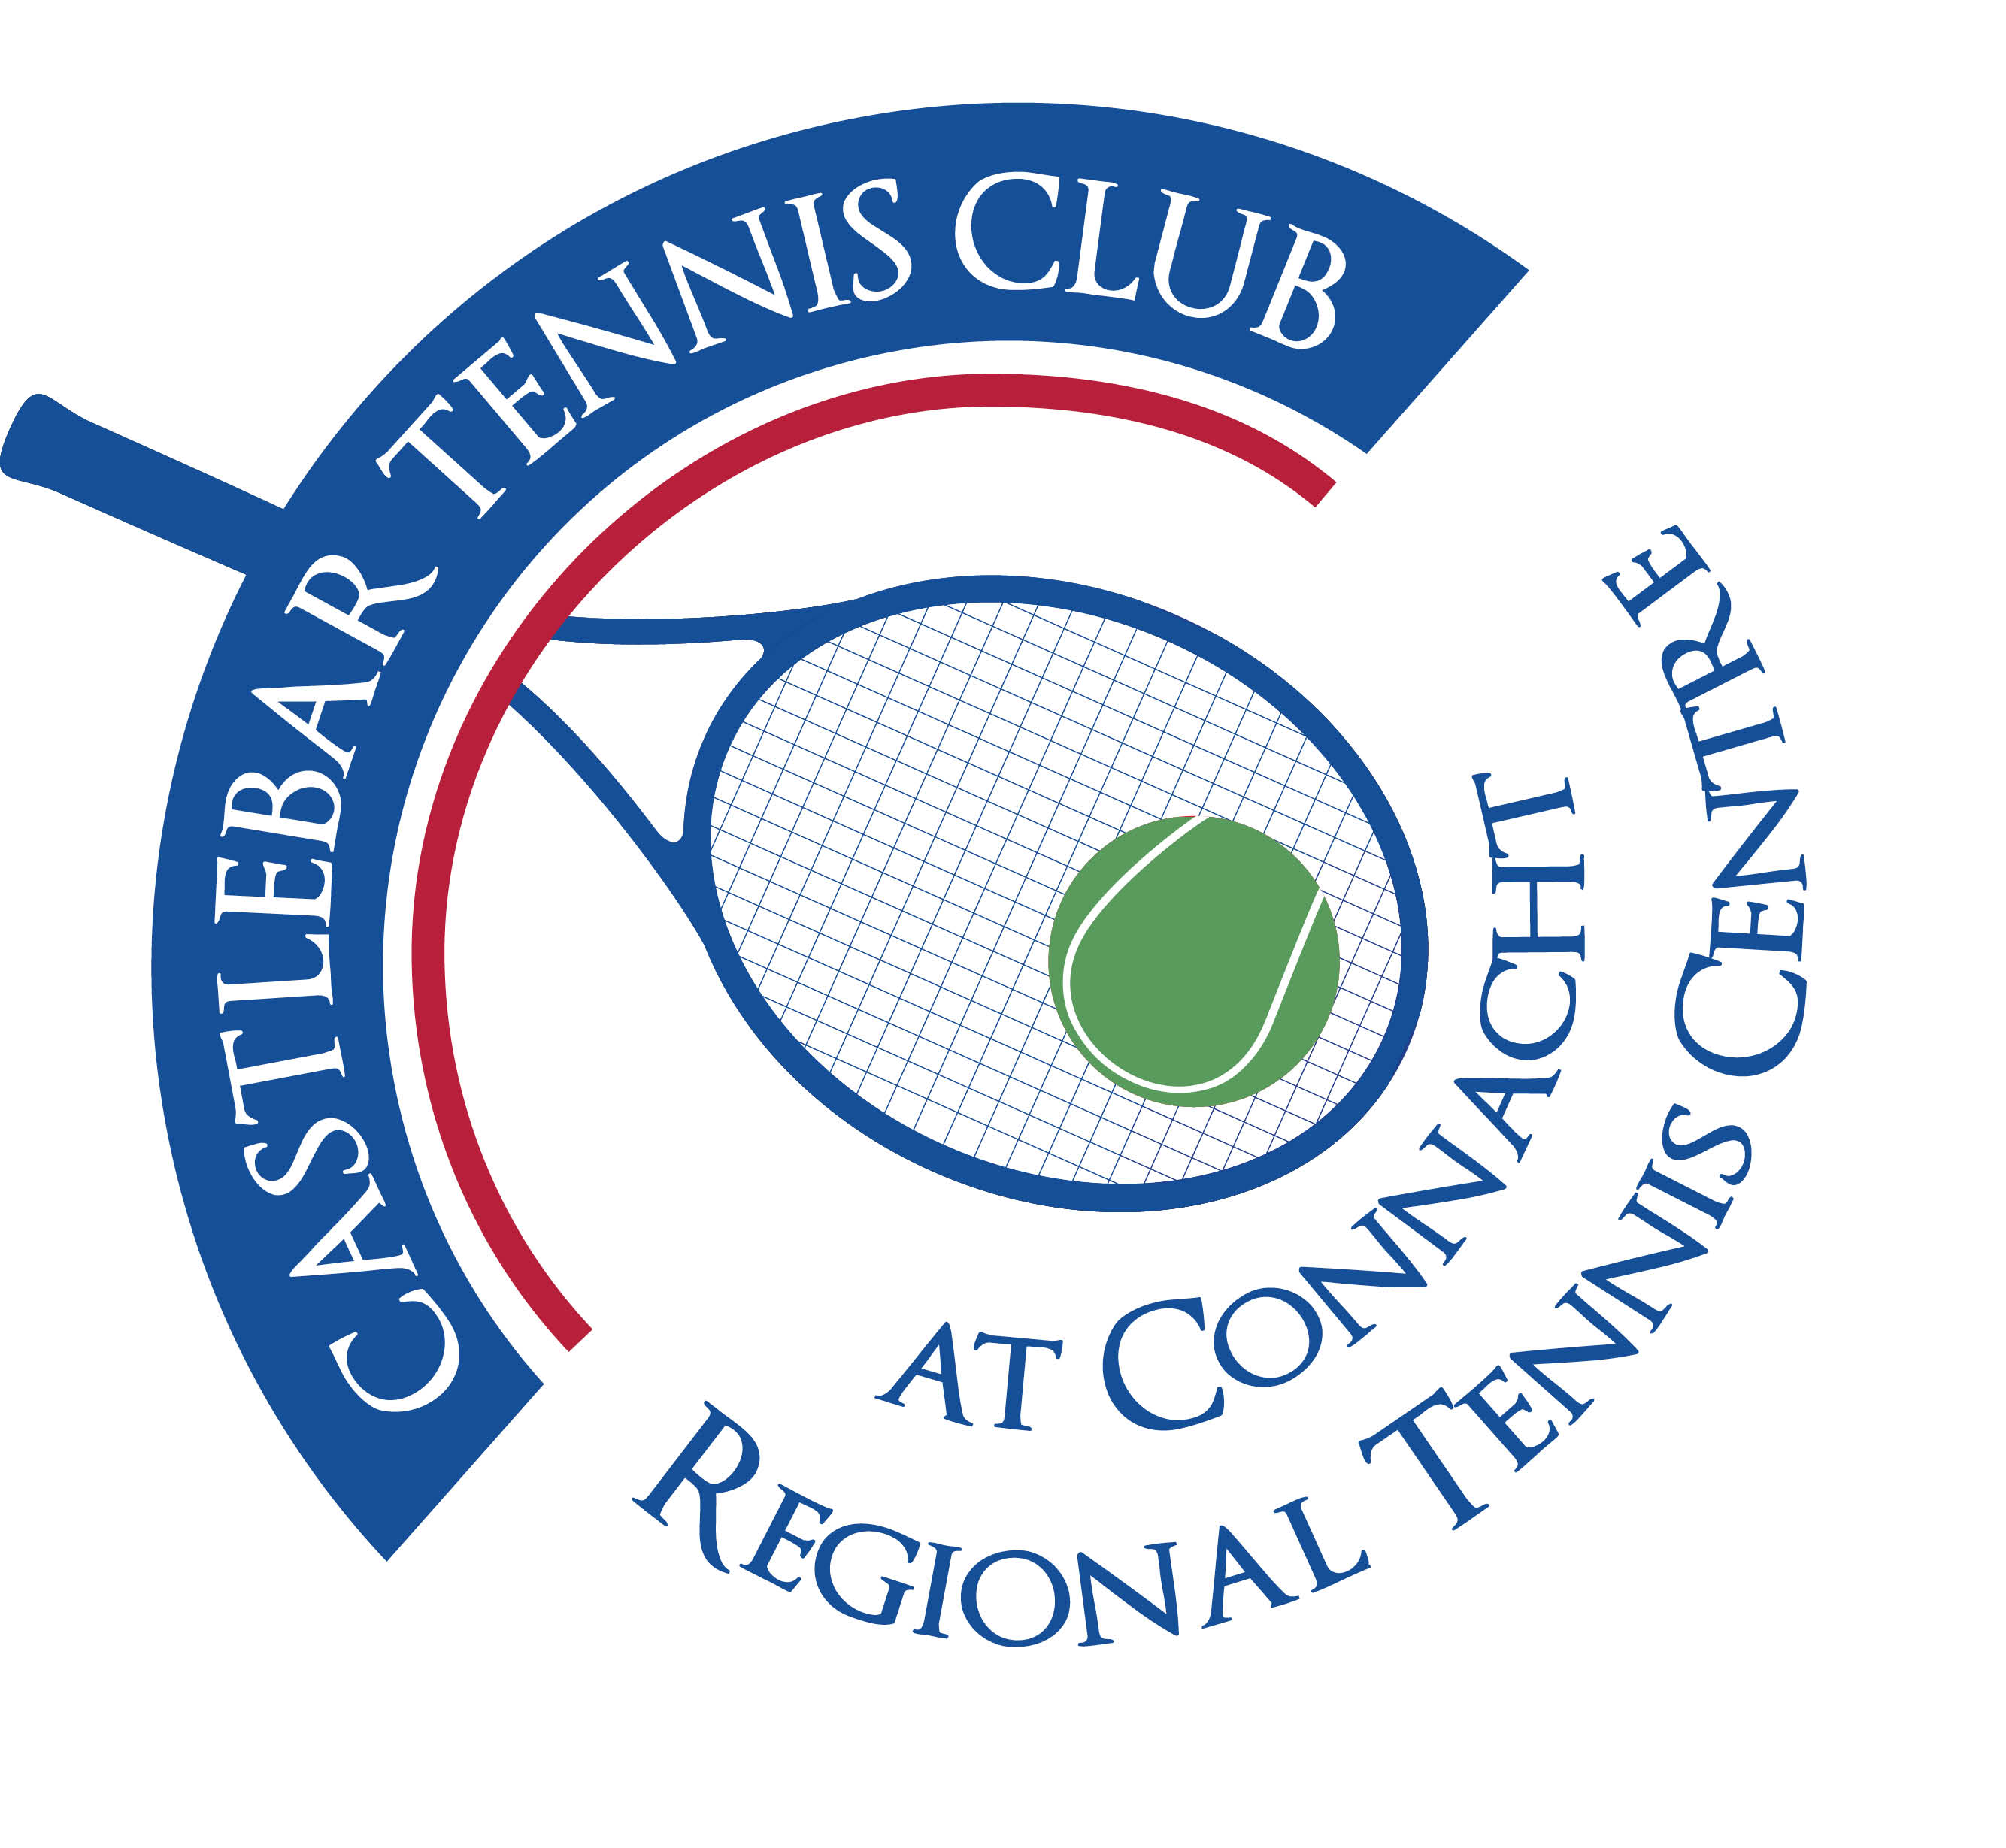
Castlebar Tennis Club
Committee Meeting
AGENDA – 20th January 2026
--------------------------------------------------------------------------------------------------------------------------

- Welcome
- Apologies
- Minutes
- Matters Arising
- Chair/Vice-Chair update & AGM
- Updates from sub committees
- Fundraising and Development
- Membership
- Financial update
- PR & Communications
- Secretary’s report
- Child Protection
- A.O.B.

Looking forward to seeing you at the meeting – should you be unable to attend, please let me know in advance.
Many thanks
John Feerick
Vice-Chairperson

