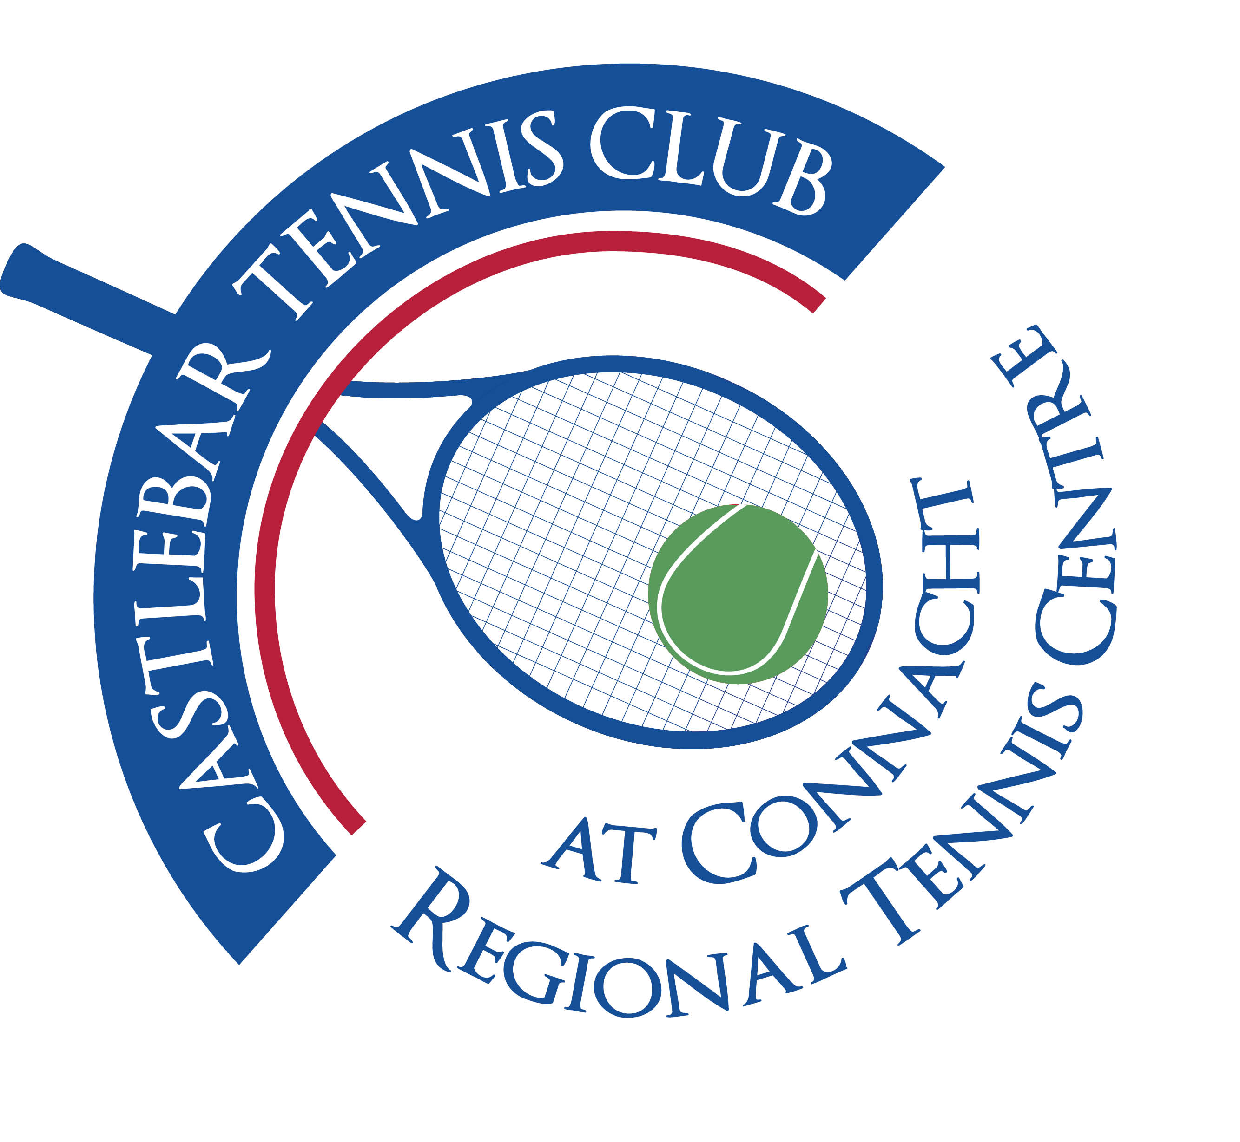
Castlebar Tennis Club
Committee Meeting
AGENDA – 17th November 2025
--------------------------------------------------------------------------------------------------------------------------

- Welcome
- Chair/Vice-Chair update
- Correspondence
- Updates from sub committees
- Fundraising and Development
- Membership
- Financial update
- PR & Communications
- Secretary’s report
- Coaches report
- Captains report
- A.O.B.

Looking forward to seeing you at the meeting – should you be unable to attend, please let me know in advance.
Many thanks
John Feerick
Vice-Chairperson

