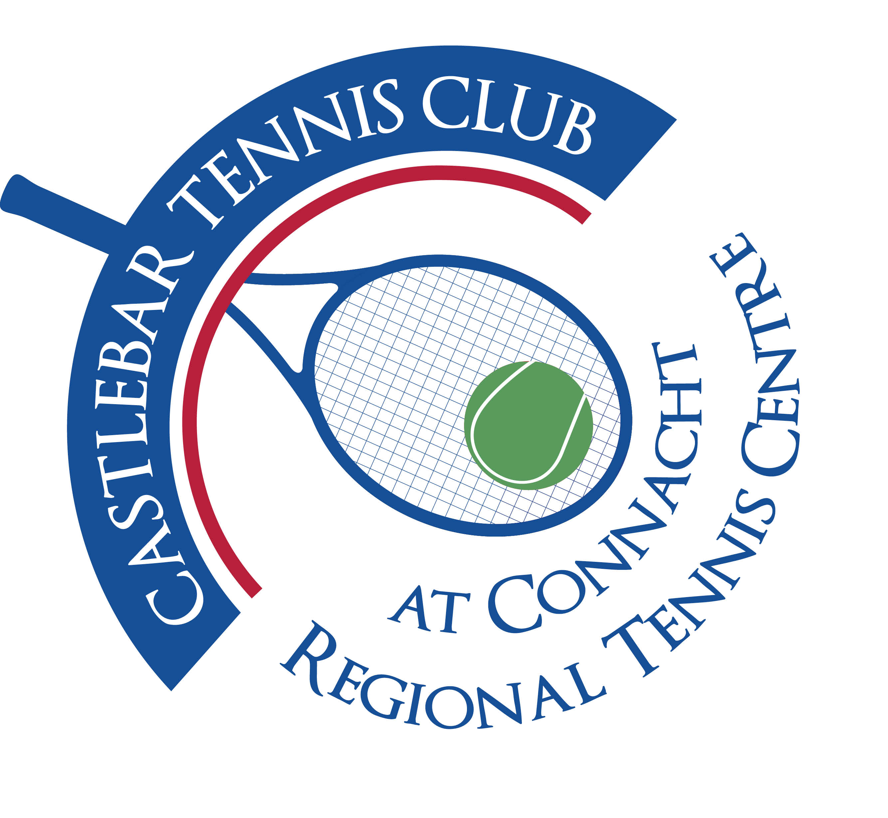

Castlebar Tennis Club

Committee Meeting

AGENDA – 13th October 2025

**--------------------------------------------------------------------------------------------------------------------------**

1. **Review & adoption of previous minutes –** Proposed by

Seconded by

1. **Welcome & Vice-Chairperson’s Update – JF**
2. **Updates from Sub-committees**

* Membership
* Fundraising & Development (incl. Update on Padel)

1. **Treasurer’s Report-NMcN**
2. **Secretary’s Report – ED**
3. **Coaching Update**
4. **PRO Report - GC**
5. **Captains Report – JG**
6. **Child Protection**
7. **AOB**

* Upcoming tournaments
* Padel trip to Galway

**Looking forward to seeing you at the meeting – should you be unable to attend, please let me know in advance.**

**Many thanks**

**John Feerick**

**Vice-Chairperson**