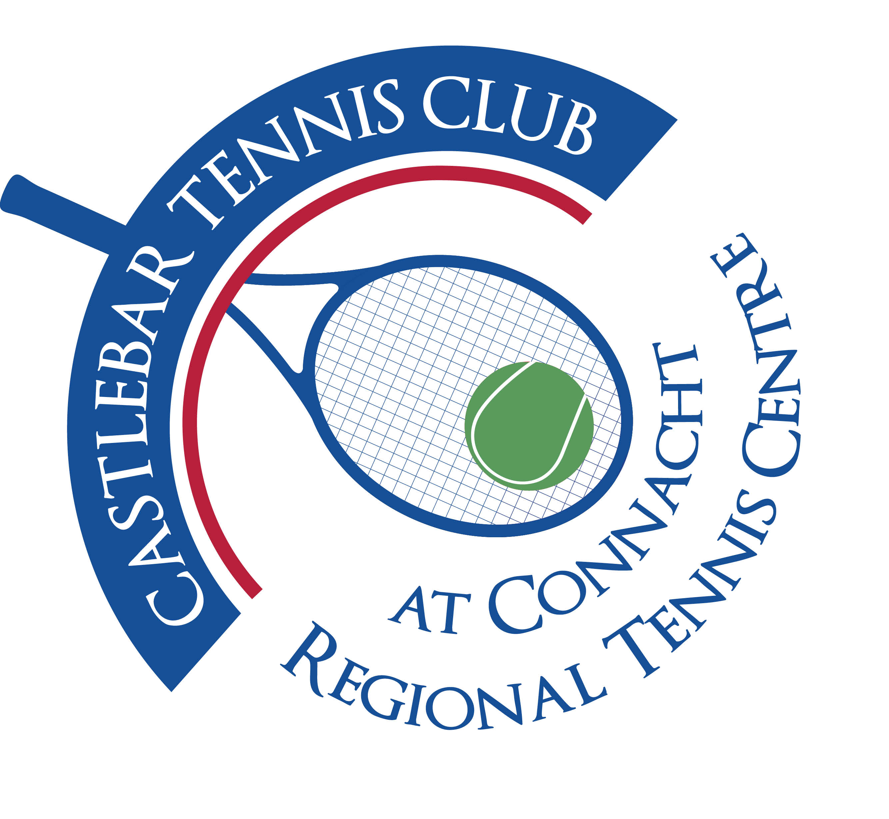

**Castlebar Tennis Club**

**AGM MINUTES**

**Thursday 13th of February 2025**

**Present:** Gráinne Cashin, Noreen McNamee, Pat Conlon, Dara Dunne, Paul Gavin, Donal Coleman, Alma Egan, Niamh Kilroy, James Durkan, Diane Kellett, Katrina Conlon, Fiona O’Malley, Paul Meldrum, John Feerick, John O’Malley, Margaret Glancy, Fiona Rowland, Mary Tighe, Emer Dunne, Patrick Quinn, Tony Mannion, Martine Dolan, Kevin Keane, John Greenan, Diarmuid Gavin, Daniel Glancy, Tom Murphy

**Apologies:** Bernie Caulfield, Patricia Ryder, Adrian Gavin

1. **Review & adoption of AGM minutes 2024**
2. **Chairperson’s Report – Patrick Quinn**

* **Introduction/Welcome and thanks** - to Anne Tobin(stepping down as Trustee), Bernie Caulfield (Stepping down as DLP), volunteers, coaches and Committee members.
* **Membership overview**-membership has remained robust despite challenges(lack of dome). Shows our members dedication to the club. Important to maintain membership levels to keep the club’s revenue at present levels. This is vital for the club’s ongoing sustainability especially as we explore options for replacing our dome.
* **Update on Dome Situation** – serious questions have been raised about the feasibility of dome structures given the increasingly frequent and intense storms we have had in recent times. Insurance companies are reluctant to provide cover. Becoming clear that a more permanent structure may be the most viable long-term solution.
* **Financial Considerations and Membership fees** - we are conscious that our members don’t have an indoor facility. We wish to keep our fees fair however we need to generate sufficient funds to make a permanent structure a reality. We are exploring other fundraising activities including court sponsorship(our first sponsored court deal has just been completed with Elverys) . We will pursue other partnerships, grants and fundraising initiatives to ensure the financial health of our club.
* **Forward Momentum** : Padel courts – Should we still proceed with installation of Padel courts given changes to our dome plans? This would require careful planning. Clubhouse upgrades – we are always looking at ways to improve existing facilities e.g.upgrading clubhouse, enhancing accessibility, improving outdoor courts, improve lighting, landscaping,etc.
* **Other Initiatives We Have Started** – **Fundraising**-Elverys court sponsorship, raffles, donation drives. **Coaching and development programmes-**coaching clinics, junior programmes, working to strengthen links with local schools. **Social and Community Engagement**-social events, tournaments, open days. **Sponsorship/Local Partnerships-**we are keen to establish more partnerships with local businesses. Create opportunities for joint events and sponsorship deals.
* **Conclusion and Good News** – Reiterate gratitude to every member for their support. Good news is that thanks to our strong membership base and sponsorships we have already secured our fundraising initiatives are off to a fantastic start. Solid foundation for future project including the possibility of a permanent indoor facility. Members ideas, feedback and support will help shape the next chapter of our club’s growth and development.

1. **Treasurer’s Report – Noreen McNamee**

* We have changed our year end to the 31st December(from 31st October)to fit in with coaching terms,etc so the following figures are for the past 14 months, as opposed to the usual 12 months.
* Noreen gave a comprehensive overview of the club’s sources of income and expenditure .

**Main Income areas for 2024:**

1. Membership – €53,580
2. Coaching- €74,992
3. Tournaments/Club Competitions - € 558 (not incl. sponsorship)
4. Hall rental - €32,088
5. Bar and vending machine - €12,462

**Total Income and Expenditure**

**14 months(to 31st Dec ‘24) 12months(to 31st Oct ’23)**

Income €291,436 €200,042

Expenditure €213,987 €169,956

**Net Income** **€77,449 €30,086**

**NEXT STEPS - FINANCE(cost cutting/revenue generation measures):**

1. Mortgage: We have €178k over 3 years left. We’re looking to refinance with Credit Union over 7-10 years to bring down repayment amounts.

Need membership approval to apply for finance(approval given)

Need assistance from trustees to apply for borrowings

1. Look at overheads to see where we can change and save
2. Revenue Generation

Carpark

Hall rental

Coaching programmes

Club Administrator

1. Member involvement/Participation

Next steps-all ideas welcome!

* Noreen finished by thanking Committee and sub-committee members, Captains James & Grainne, Club President Paul Gavin, Club Trustees(Special mention to Anne Tobin) and Brendan O’Hara(Club Accountant).
* The question was asked do we need to replace trustees that retire? The answer is no we don’t have to, but it would practice to.

1. **Coaching Report – Garrett Barry**

**Coaching Team:**

* + Jan Frydrych
  + Daniel Glancy
  + Garrett Barry
  + Dylan McGuinn - S&C Coach

**Inclusion projects 2024**

* ***School Autism Units:*** Derrywash, Castlebar Primary School and Breaffy availed of programmes.
* ***Enjoy Tennis ID sessions:*** We worked with numerous groups to deliver tennis for people with intellectual disabilities including Western Care Castlebar and Achill, NLN, Rehab Care, and St Anthonys Special School.
* ***ASD and Inclusion Camps:*** As part of our summer camp programmes, we had spaces made available for kids with autism/adhd and also spaces available for children from International Protection Centres and Ukrainians.
* ***Blind/VI Tennis:*** 5 adults and 4 children take part in weekly coaching sessions and will compete in Naas on March 23rd.
* ***Olwyn O Toole:*** Olwyn stepped down from the coaching team in June 2024. This has caused a marked decline in Inclusion Projects in Castlebar TC

**Junior Coaching Program**

* Castlebar TC coaching currently 79 juniors in coaching
* 6 Recreational Group Sessions run between Monday/Tuesday/Wednesday & Friday
* Castlebar TC has always boasted a best-in-class performance program.
* 28 tournament/squad players including:
  + #1 Irish Ranked girl U16
  + Recent National Indoor U18 boys Champion and girls U16 Runner Up
  + #1 U12, U14 & U16 Boys & #1 U12/U14 & U16 Girls in Connacht
  + 9 out of the 18 players that represented Connacht in the Junior Interprovincials from Castlebar TC
* Squads run on Mon/Tue/Wed & Fri

**Adult Coaching**

* Sessions that ran in 2024
  + 2 Couch to Court sessions
  + 2 Adult Clinics
  + 2 Summer Camps
  + 3 Adult coaching groups
  + Friday Morning Coaching
* Our coaching program has taken quite a hit in recent terms. We are down from over 100 kids to just over 80. When I ask parents why their son/daughter is not coming back to lessons, they unanimously state, that it is due to the lack of a ‘guarantee’ of coaching taking place. As we know, the weather is deteriorating every year and the lack of an indoor facility (of which everyone had gotten used to in Castlebar) is making it increasingly difficult to sustain our coaching numbers. It is also very difficult to get new players as we can’t confidently promote our programs.
* The lack of indoors also affects our performance program. Recently (and to their ultimate credit for doing as well as they did) our national junior finalist and winner were only able to train for 2 days the week before the National indoors (both sessions in Claremorris). Thankfully they had lots of work done and were able to do as well as they did but this wont always be the case.
* While we had the luxury of dome for 12 years, we now need to decide on a pathway forward. Are we back to being an outdoor club? Are we going to find an alternative indoor solution? Is a dome an option for Castlebar anymore?
* How we spend money etc. will depend on the answers from above, however, what we can do in the interim is make sure our ‘outdoor’ lights are fit for purpose.
* Finally, please feel free to contact me on 087 2935322 if you have any questions around our coaching program for 2025.

Garrett Barry

1. **Child Protection Report – Bernie Caulfield**

* Earlier this year it was brought  to our attention that Sean McGranaghan, who worked as a coach at our club from September 2021 to June 2022 (on Wednesdays for four hours), had been sentenced to six and a half years in prison in England for sexual offences.  This coach had been Garda vetted and we had no reports of any incidents occurring during his time at our Club.  We made a report to the Garda Station in Castlebar for their advice and guidance.
* I have written to the Committee about my concerns about our car park being used by patrons of the leisure centre and the safety concerns relating to pedestrians walking through gate and oncoming traffic especially when children are attending swimming lessons.  A separate gate and walkway for pedestrians is required if we are to continue to allow parking in our Club for Leisure Centre users to avoid walking through the main gate which was only ever intended to be used by cars and not pedestrians.
* As I mentioned at the last AGM I am stepping down now as Designated Liaison Person and we now need someone in the Club to volunteer to take up this role.  I would like to take this opportunity to thank our 2 Children’s Officers Salim Kahn and AnnMarie O’Reilly and everyone who supported me while I was in this role.

1. **Election of officers.**

**(i)President Nominee: Paul Gavin**

Proposed by: Patrick Quinn

Seconded by: Donie Coleman

**(ii) Chairperson Nominee: Patrick Quinn**

Proposed by: Donie Coleman

Seconded by: Paul Meldrum

**(iii)Vice-chairperson Nominee: John Feerick**

Proposed by:Patrick Quinn

Seconded by:Noreen McNaMee

**(iv) Secretary Nominee: Emer Dunne**

Proposed by: Gráinne Cashin

Seconded by: Alma Egan

**(v) Treasurer Nominee: Noreen McNamee**

Proposed by: Patrick Quinn

Seconded by: Tony Mannion

**(vi) Men’s Captain Nominee: John Greenan**

Proposed by: Tony Mannion

Seconded by: James Durkan

**(vii) Ladies Captain Nominee: To be co-opted later.**

**(viii) Committee members** :

**Paul Meldrum**

**Tony Mannion**

**Alma Egan**

**John O’Malley**

**Niamh Kilroy**

**Fiona O’Malley**

**Grainne Cashin**

**James Durkan**

1. **Q & A –Discussion**

* Structure to replace Dome?

Permanent structure to cover 4 courts will cost approx. €1.2m. Possibility of an aluminium structure (ballpark cost €510k pending an assessment of our grounds,etc.)that could be suitable. Sides can be taken down. Members of Dome sub-committee to meet company next week.

* Sporting arena being established over at the pool area. €7 million being spent. Could we team up with them? Need help/funding-contact Alan Dillon?
* Diarmuid: We are Connacht Regional Centre for Tennis. Need a solid structure that will withstand the winters to come. We’re losing members. We need to sell our vision and members will come. We need to target the town/newspapers,etc Get a large picture/visual up of what our structure will look like/what our future looks like. We could sell portion of grassy land inside the gate to the council to raise funds. We have space for padel behind clay courts.
* Tom: We need to look at all options. Perhaps lease land inside gate as opposed to selling. Think big!
* Paul G: We also have room for 2 more courts out beyond court 2, in the process of clearing the land.
* Noreen: Think now is not right time to pursue Padel. It would use up most of our savings. Also the more often you apply for/use Sports Capital Grant funding the less chance you have of getting a higher amount again(you lose points).
* Donie: Has quote from APM for a barrier with a QR code to enter/exit which can’t be passed on to other users(ie non-members).

**Cost:** €8650 for barriers

€2875 for ground works

€1200 for electrical works(bringing power out to the gate)

It would be important to let the public know in advance of the barrier being installed.

* John F: Is there a need for a part-time admin/manager role? Incentivise to attract and retain members.

Grants are available for solar panels. Our energy costs seem to have jumped. Probably more expensive to use the outdoor light than the dome lights. Need better timers?

Noreen mentioned that apparently our night-time energy usage is huge! This will be reviewed and a report will be given to the committee.

Fiona R: Church in Newport have installed insect-friendly lights – may be grant,etc available for something like this?

* Fiona O’M: We have very few members in 20/30 age bracket- too expensive, have to pay for membership and then coaching in addition.

We need a membership drive but also the infra-structure there to support new members!

* Plan is to have a think-tank meeting-all members welcome with ideas/initiatives on how to move forward!

Diarmuid & Tom: put a development committee together for the next stage of the club. Get other sub-committees up & running again(Junior/bar/maintenance,etc). A member of the committee to be chairperson of each sub-committee. It is paramount that the indoor facility is of utmost importance. Need lot sooner than 5 years. Important to keep going, keep social spirit of the club alive.

* James: we struggled to raise the €350k needed for replacement dome. Political help wasn’t there for us. Will take a lot to get 800k! We’ll have to push hard.
* Grainne: Disappointing to get €99k in SCG. We had applied for €170k.
* Tom: The structure is bigger than the club. We need the whole town and further afield to help. Members can’t do it on their own. But the support for our club is there!
* Alma: we needs to show how we can sell it (indoor facility)to the community.
* Diarmuid: We need to figure out what is required-‘This is what it will look like. This is what it will cost’etc. Then we can lobby. Put it into the papers/ approach politicians. Get sub-committees especially development committee going. It worked before!
* Tony: It’s important to note/acknowledge that the dome sub-committee had a lot of work done. This is all gone since the dome came down in Galway. Everything has changed in the last month. We’ve also had disappointments(community recognition funding), we need to decide who to go with/target for funding.
* Diane: is it likely we would get planning for what we want?(indoor structure). We need to look at this.
* Diane: Could we get regular updates again for members? Fizzled out a bit last year. Gives an appreciation of the level of work being done by the committee.
* John F: Quiz next Friday night 21st February at 8pm. Please support!
* Katrina: Membership rates remaining the same?(renewal time is approaching). We can’t afford to change rates.

No objections to this so membership rates will remain unchanged.

**____________________________**

**Emer Dunne**

**Hon. Secretary**